Web Security Threat Detection
A Project Report Submitted to
QIS College of Engineering & Technology, Ongole in the Partial Fulfilment for the Award of the Degree MASTER OF COMPUTER APPLICATIONS

Submitted by: KUNCHALA HEMANTH (23491F0011)

Under the Esteem Guidance of Mr. B. AMARNATH REDDY M.Tech.,


DEPARTMENT OF
MASTER OF COMPUTER APPLICATIONS
QIS COLLEGE OF ENGINEERING &TECHNOLOGY
(AUTONOMOUS)

Approved by AICTE | Permanent Affiliation: JNTU-Kakinada UGC- Recognized |Accredited by NAAC | ISO9001:2015Certified Vengamukkapalem(V), Ongole, Prakasam, Andhra Pradesh- 523272

2023-2025

QIS COLLEGE OF ENGINEERING & TECHNOLOGY
(AUTONOMOUS)
Approved by AICTE| Permanent Affiliation: JNTU-Kakinada UGC- Recognized|AccreditedbyNAAC|ISO9001:2015 Certified
Vengamukkapalem(V), Ongole, Prakasam dist., Andhra Pradesh- 523272



DEPARTMENT OF
MASTER OF COMPUTER APPLICATIONS

BONAFIDE CERTIFICATE
This is to certify that the dissertation entitled “Web Security Threat Detection”, was successfully carried out by KUNCHALA HEMANTH (23491F0011), QISCET, Ongole, in the partial fulfillment for the award of the degree of “MASTER OF COMPUTER APPLICATIONS” for the Academic Year of 2024-25.

Signature of the Guide Signature of the Head of the Dept.
B. AMARNATH REDDY Dr. S. KONDALA RAO
M.Tech., M.Phill., Ph.D., MLSI., MISTE.,

Signature of the External Examine

ACKNOWLEDGEMENT
The satisfaction and euphoria that accompany the successful completion of the project would be incomplete without the mention of the people who made it possible. I consider it my privilege to express my gratitude and respect to all those who guided and inspired in the successful completion of my project.
It is with great pleasure that, I acknowledgment my sincere thanks and deep sense of gratitude to my Mentor Mr. B. AMARNATH REDDY, Assistant Professor, Department of MCA, for his valuable guidance throughout the Internship. No words will be adequate to quantify his support inspiration and coordination. His unflinching help, suggestions, directions and guidance have helped in progress of the project work. His professional attitude and human qualities are a source of my inspiration and model for me to follow.
I acknowledge my sincere gratitude to Dr. S. KONDALARAO, Head of the Department of Master of Computer Applications, for his encouragement and providing sufficient computational facilities to successfully complete the project work.
I am grateful to our Principal Dr. Y. V. HANUMANTHA RAO, for providing me an opportunity to utilize the Infrastructural facilities and computational facilities of project at QIS College of Engineering & Technology, Ongole and allowing availing the entire faculty in the college.
I sincerely thank full to all the Faculty and Technical Staff of Master of Computer Applications department for their whole hearted help during the course of my work.

KUNCHALA HEMANTH
(23491F0011)

i

DECLARATION
I hereby declare that this report for the project title “Web Security Threat Detection” has been developed by me under the able supervision of Mr. B. AMARNATH REDDY Assistant Professor and submitted to Department of Master of Computer Applications, QIS College Of Engineering and Technology, Ongole, for partial fulfilments of requirement of my project work. It is my own and not submitted to any other college/university or published by time.

KUNCHALA HEMANTH
(23491F0011)

ABSTRACT
Web applications play a crucial role in modern society, offering a wide range of services from e-commerce to social networking. However, they are also a common target for cyberattacks due to their complexity and the vast amount of sensitive information they handle. Web vulnerabilities, such as SQL injection, cross-site scripting (XSS), and cross-site request forgery (CSRF), pose significant threats to the security of web applications and their users.This paper provides an overview of common web vulnerabilities, their impact, and current approaches for mitigating them. We discuss the importance of secure coding practices, regular security audits, and the use of security tools and frameworks to protect web applications from potential attacks. Additionally, we explore emerging trends and technologies, such as machine learning and artificial intelligence, that show promise in improving web application security.By understanding the nature of web vulnerabilities and implementing appropriate security measures, developers and organizations can enhance the security posture of their web applications and protect against potential threats.

TOPICS | PAGE NO
ACKNOWLEDGEMENT | I
DECLARATION | Ii
ABSTRACT | Iii
CHAPTER 1: INTRODUCTION | 1
1.1 Introduction | 1
1.2 Existing System | 1
1.3Proposed System | 2
CHAPTER 2: LITERATURE SURVEY | 3
CHAPTER 3: SYSTEM ANALYSIS | 6
3.1 Introduction | 6
3.2 Feasibility Study | 6
3.2.1 Economical Feasibility | 6
3.2.2 Technical Feasibility | 6
3.2.3 SOCIAL Feasibility | 7
3.3 System Requirements Specifications | 7
3.3.1 Functional Requirements | 7
3.3.2 Non-Functional Requirements | 8
3.3.3 Software Development Life Cycle | 8
3.4Software Requirements | 14
3.5 Hardware Requirements | 14
CHAPTER 4: SYSTEM DESIGN | 15
4.1 System Architecture | 15
4.2 UML Diagram | 15
4.2.1 Use Case Diagram | 16
4.2.2 Class Diagram | 17
4.2.3 Sequence Diagram | 17
4.2.4 Activity Diagram | 18
4.2.5 Collrabation Diagram | 18
4.3 Input and out put Designs | 18
4.3.1 Input | 18
4.3 2 out put Designs | 18
CHAPTER 5: IMPLEMENTATION | 20
5.1 Software Environment | 20
5.2 Python | 24
5.3 Sample code | 42
CHAPTER 6: SYSTEM TESTING | 45
6.1 Types of Testing | 45
6.2 Test Cases | 51
CHAPTER 7: CONCLUSION AND FUTURE ENHANCEMENT | 53
CHAPTER 8: REFERENCES | 56
CHAPTER 9: APPENDIX | 58
CHAPTER 10: EXECUTION PROCEDURE | 60

LIST OF FIGURES

S.NO | FIGURE NO. | FIGURE NAME | PAGE NO.
1 | 3.3.3 | Software Development Life Cycle | 8
2 | 4.1.1 | System architecture | 15
3 | 4.2.1 | Use-Case Diagram | 16
3 | 4.2.2 | Class Diagram | 17
4 | 4.2..3 | Sequence Diagram | 17
5 | 4.2.4 | Activity Diagram | 18
6 | 4.2.5 | Collrabation Diagram | 18
7 | 6.0 | Software Testing Categories | 45
8 | 6.1 | Types of Testing | 45

LIST OF SCREENS

S.NO | SCREEN NO. | SCREEN NAME | PAGE NO.
1 | 10.1 | Start of Python Server | 60
2 | 10.2 | Admin Home Page | 61
3 | 10.3 | Admin Signup page | 61
4 | 10.4 | Run Test Algorithm | 62
5 | 10.5 | Algorithms Performance Screen | 63
6 | 10.6 | Decision Tree Confusion Screen | 63
7 | 10.7 | Light GBM Screen | 64
8 | 10.8 | Phishing URL Detection Screen | 65

  - INTRODUCTION

CHAPTER 1 INTRODUCTION

Web applications play a crucial role in modern society, facilitating various online activities such as e-commerce, social networking, and information sharing. However, the widespread use of web applications also makes them a target for malicious actors seeking to exploit vulnerabilities for nefarious purposes. Web vulnerabilities can lead to data breaches, financial loss, and damage to an organization's reputation.Web vulnerability refers to a weakness or flaw in a web application that can be exploited by attackers to compromise the security of the application or the data it processes. These vulnerabilities can exist at various levels of the web application stack, including the web server, application server, database server, and client-side scripts.Common web vulnerabilities include SQL injection, cross-site scripting (XSS), cross-site request forgery (CSRF), and insecure direct object references. These vulnerabilities can be exploited to steal sensitive information, modify data, or execute malicious code on the user's device.In recent years, the number and complexity of web vulnerabilities have increased, driven by the growing sophistication of attacks and the rapid evolution of web technologies. As a result, organizations must take proactive measures to identify and mitigate web vulnerabilities to protect their assets and maintain the trust of their users.

EXISTING SYSTEM
The existing system for managing web vulnerabilities typically involves a combination of manual code reviews, automated vulnerability scanning tools, and the use of secure coding practices. Manual code reviews are conducted by experienced developers to identify potential vulnerabilities in the source code, such as SQL injection, XSS, and CSRF. While effective, manual reviews can be time-consuming and may not catch all vulnerabilities, especially in large and complex web applications.Automated vulnerability scanning tools are used to detect common vulnerabilities in web applications automatically. These tools can quickly scan a web application for known vulnerabilities and provide a report of issues that need to be addressed. However, automated tools may generate false positives or false negatives, requiring manual verification and validation.Secure coding practices, such as input validation, parameterized queries, and output encoding, are essential for preventing vulnerabilities in web applications.

Developers are encouraged to follow secure coding guidelines and best practices to reduce the risk of introducing vulnerabilities during the development process.
DRAW BACKS

Manual Effort: Manual code reviews are time-consuming and labor-intensive, making them impractical for large-scale web applications or frequent code changes.
Limited Coverage: Automated vulnerability scanning tools may not detect all vulnerabilities, especially those that require complex or context-dependent analysis.
  - PROPOSED SYSTEM
The proposed system for managing web vulnerabilities aims to address the limitations of the existing system by leveraging advanced technologies and approaches. One key aspect of the proposed system is the integration of automated vulnerability scanning tools with machine learning algorithms.By using machine learning, the system can improve the accuracy of vulnerability detection and reduce false positives and false negatives. Machine learning models can be trained on large datasets of known vulnerabilities to recognize patterns and anomalies in web application code, making them more effective at identifying potential vulnerabilities.Another key component of the proposed system is the use of continuous security testing and monitoring. Rather than relying on periodic scans or manual reviews, the system continuously monitors web applications for vulnerabilities and alerts developers in real-time. This proactive approach allows vulnerabilities to be identified and addressed promptly, reducing the risk of exploitation.Additionally, the proposed system emphasizes the importance of secure coding practices and developer training. Developers are provided with tools and resources to help them write secure code, such as secure coding guidelines and automated code analysis tools. Regular training sessions and workshops are also conducted to raise awareness about web vulnerabilities and best practices for mitigating them.

ADVANTAGES
Improved Accuracy: By leveraging machine learning, the proposed system can improve the accuracy of vulnerability detection, reducing false positives and false negatives compared to traditional automated tools.
Real-time Monitoring: The proposed system offers real-time monitoring of web applications for vulnerabilities, allowing for prompt detection and mitigation of security issues.
Proactive Approach: Continuous security testing and monitoring enable a proactive approach to managing web vulnerabilities, reducing the risk of exploitati

CHAPTER 2

LITERATURE SURVEY

Huang et al. (2003) – “Web Application Security Assessment by Fault Injection and Behavior Monitoring”
Approach:
Dynamic analysis by fault injection to discover vulnerabilities.

Merits:
Can detect runtime vulnerabilities.
Works without needing access to source code.

Demerits:
High false positives.
Requires significant computational resources.

Williams and Wichers (2006) – OWASP Top Ten Project Approach:
Community-driven list identifying the top 10 critical web application security risks.

Merits:
Widely accepted and updated regularly. Educates developers and auditors.

Demerits:
Descriptive but not a detection method. Not exhaustive; only covers the top 10.

Musch, M. et al. (2018) – “A Survey on Web Application Vulnerability Detection Tools”
Approach:
Comparative study of static, dynamic, and hybrid tools.

Merits:
Evaluates real-world tools.

Identifies gaps in coverage and performance.

Demerits:
Lacks original detection techniques. Results may vary based on test cases.

Fonseca et al. (2007) – “Testing and Comparing Web Vulnerability Scanning Tools for SQL Injection and XSS Attacks”

Approach:
Empirical evaluation of scanning tools like Acunetix, Nessus, etc.

Merits:

Practical relevance for developers and testers. Highlights strengths and weaknesses of each tool. Demerits:
Limited to specific attack types (SQLi, XSS). May not reflect newer vulnerabilities.

Antunes & Vieira (2015) – “Comparing the Effectiveness of Penetration Testing and Static Code Analysis”
Approach:
Comparison of static code analysis vs. penetration testing.

Merits:
Highlights trade-offs between early detection and real-world simulation. Useful for choosing the right technique.

Demerits:
Does not provide new detection algorithms. Static analysis may miss logic flaws.

Doupe et al. (2010) – “Wepawet: An Automated Web Exploit Detection System for JavaScript”
Approach:
Automated dynamic analysis of JavaScript code.

Merits:
Effective against obfuscated malware. Scalable cloud-based implementation. Demerits:
Focuses only on client-side code. May not detect server-side issues.

Li et al. (2011) – “Parameterized Unit Testing for Web Security”
Approach:
Uses unit testing with parameters to test web apps.

Merits:
Integrates with development workflows. Low false positives.

Demerits:
Requires developer expertise.
Not effective without thorough test coverage.

  - INTRODUCTION

CHAPTER 3 SYSTEM ANALYSIS

Web applications play a crucial role in modern society, facilitating various online activities such as e-commerce, social networking, and information sharing. However, the widespread use of web applications also makes them a target for malicious actors seeking to exploit vulnerabilities for nefarious purposes. Web vulnerabilities can lead to data breaches, financial loss, and damage to an organization's reputation.Web vulnerability refers to a weakness or flaw in a web application that can be exploited by attackers to compromise the security of the application or the data it processes. These vulnerabilities can exist at various levels of the web application stack, including the web server, application server, database server, and client-side scripts.Common web vulnerabilities include SQL injection, cross-site scripting (XSS), cross-site request forgery (CSRF), and insecure direct object references. These vulnerabilities can be exploited to steal sensitive information, modify data, or execute malicious code on the user's device.In recent years, the number and complexity of web vulnerabilities have increased, driven by the growing sophistication of attacks and the rapid evolution of web technologies. As a result, organizations must take proactive measures to identify and mitigate web vulnerabilities to protect their assets and maintain the trust of their users.
  - FEASIBILITY STUDY
The feasibility of the project is analyzed in this phase and business proposal is put forth with a very general plan for the project and some cost estimates. During system analysis the feasibility study of the proposed system is to be carried out. This is to ensure that the proposed system is not a burden to the company. For feasibility analysis, some understanding of the major requirements for the system is essential.

ECONOMICAL FEASIBILITY
This study is carried out to check the economic impact that the system will have on the organization. The amount of fund that the company can pour into the research and development of the system is limited. The expenditures must be justified. Thus the developed system as well within the budget and this was achieved because most of the technologies used are freely available. Only the customized products had to be purchased.

TECHNICAL FEASIBILITY
This study is carried out to check the technical feasibility, that is, the technical requirements of the system. Any system developed must not have a high demand on the available technical resources. This will lead to high demands on the available t echnical resources. This will lead to high demands being placed on the client. The developed system must have a modest requirement, as only minimal or null changes are required for implementing this system.

SOCIAL FEASIBILITY

The aspect of study is to check the level of acceptance of the system by the user. This includes the process of training the user to use the system efficiently. The user must not feel threatened by the system, instead must accept it as a necessity. The level of acceptance by the users solely depends on the methods that are employed to educate the user about the system and to make him familiar with it. His level of confidence must be raised so that he is also able to make some constructive criticism, which is welcomed, as he is the final user of the system.
  - SYSTEM REQUIREMENT SPECIFICATION

Functional Requirements
Threat Detection – Identify common web vulnerabilities such as SQL Injection, Cross-Site Scripting (XSS), and Cross-Site Request Forgery (CSRF).
Penetration Testing – Simulate real-world cyberattacks to assess security weaknesses.

Access Control & Authentication – Implement user authentication mechanisms (e.g., multi- factor authentication).
Encryption & Data Protection – Secure data in transit and at rest using cryptographic protocols like SSL/TLS.
Security Logging & Monitoring – Maintain logs of access, errors, and suspicious activities.

Firewall & Intrusion Detection – Use Web Application Firewalls (WAF) and Intrusion Detection Systems (IDS) to block malicious traffic.
Automatic Patch Management – Detect and update vulnerable components automatically.

User Session Management – Prevent session hijacking and fixation attacks.

Security Auditing & Reporting – Generate vulnerability assessment reports for compliance and analysis.
API Security – Protect APIs from attacks like API scraping, broken authentication, and unauthorized access.

Non-Functional Requirements:

Scalability – Handle large web applications with minimal performance impact.

Performance – Ensure low latency while running security checks.

Usability – Provide intuitive security interfaces for developers and security teams.

Reliability – Maintain system uptime and availability even under attack.

Security & Privacy – Adhere to security best practices to prevent unauthorized data access.

Interoperability – Work seamlessly with various web platforms, frameworks, and cloud services.
Maintainability – Allow easy updates to adapt to new attack vectors.

Compliance – Follow security standards such as OWASP, GDPR, and PCI-DSS.

Logging & Auditing – Provide detailed logs for forensic analysis and regulatory compliance.

Energy Efficiency – Optimize resource consumption during security scans.

Software Development Life Cycle (SDLC)
Software development life cycle (SDLC) is a structured process that is used to design, develop, and test good-quality software. SDLC, or software development life cycle, is a methodology that defines the entire procedure of software development step-by-step. The goal of the SDLC life cycle model is to deliver high-quality, maintainable software that meets the user's requirements. SDLC in software engineering models outlines the plan for each stage so that each stage of the software development model can perform its task efficiently to deliver the software at a low cost within a given time frame that meets users requirements. In this article we will see Software Development Life Cycle (SDLC) in detail.

What is the Software Development Life Cycle (SDLC)?

SDLC is a process followed for software building within a software organization. SDLC consists of a precise plan that describes how to develop, maintain, replace, and enhance specific software. The life cycle defines a method for improving the quality of software and the all- around development process.
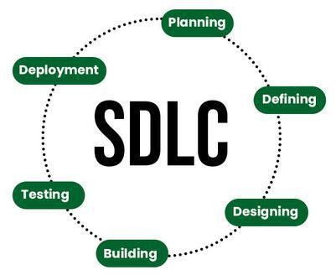

Stages of the Software Development Life Cycle

SDLC specifies the task(s) to be performed at various stages by a software engineer or developer. It ensures that the end product is able to meet the customer's expectations and fits within the overall budget. Hence, it's vital for a software developer to have prior knowledge of this software development process. SDLC is a collection of these six stages, and the stages of SDLC are as follows:

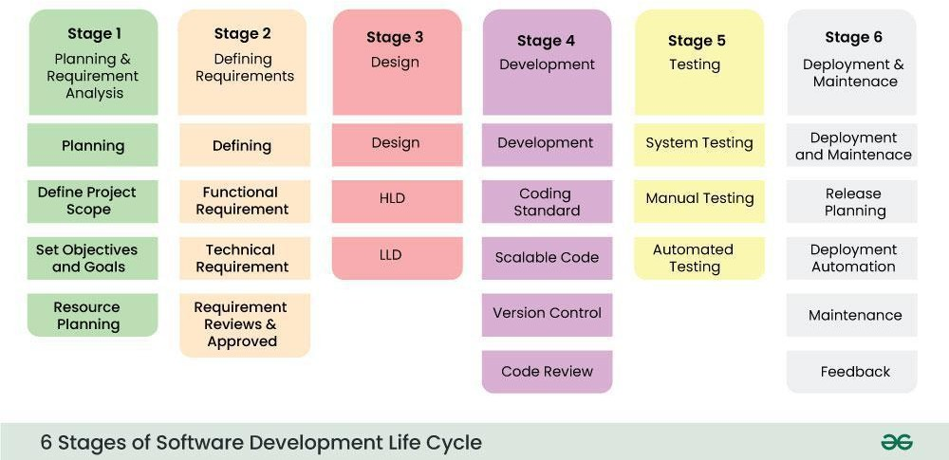

Model SDLC Stages

The SDLC Model involves six phases or stages while developing any software.

Stage-1: Planning and Requirement Analysis

Planning is a crucial step in everything, just as in software development. In this same stage, requirement analysis is also performed by the developers of the organization. This is attained from customer inputs, and sales department/market surveys.
The information from this analysis forms the building blocks of a basic project. The quality of the project is a result of planning. Thus, in this stage, the basic project is designed with all the

available
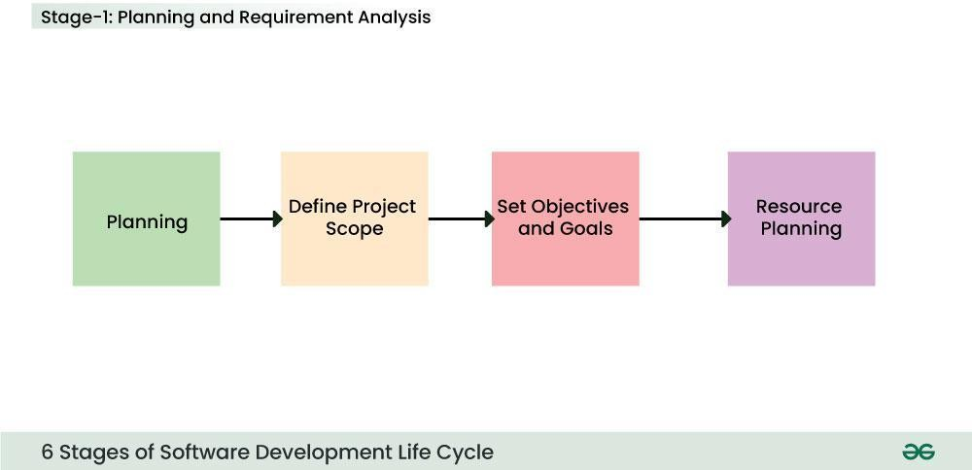

Stage-2: Defining Requirements

In this stage, all the requirements for the target software are specified. These requirements get stakeholders.
This is fulfilled by utilizing SRS (Software Requirement Specification). This is a sort of

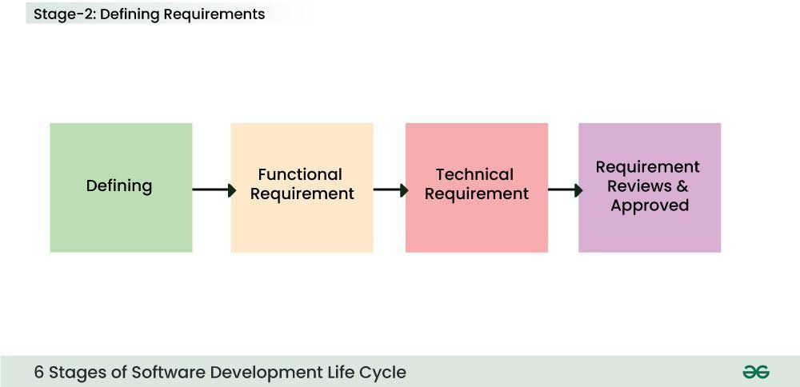

document that specifies all those things that need to be defined and created during the entire project cycle.
Stage-3: Designing Architecture
SRS is a reference for software designers to come up with the best architecture for the software. Hence, with the requirements defined in SRS, multiple designs for the product architecture are present in the Design Document Specification (DDS).

. 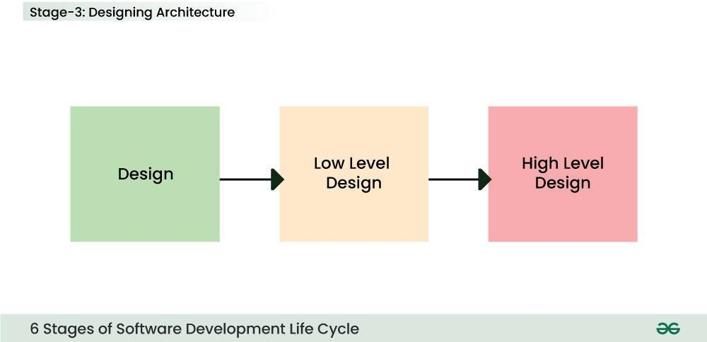
Stage-4: Developing Product
At this stage, the fundamental development of the product starts. For this, developers use a specific programming code as per the design in the DDS. Hence, it is important for the coders to follow the protocols set by the association. Conventional programming tools like compilers, interpreters, debuggers, etc. are also put into use at this stage. Some popular languages like C/C++, Python, Java, etc. are put into use as per the software regulations.
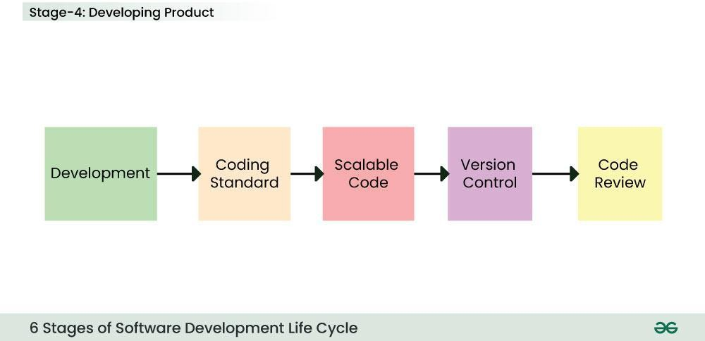

Stage-5: Product Testing and Integration

After the development of the product, testing of the software is necessary to ensure its smooth execution. Although, minimal testing is conducted at every stage of SDLC. Therefore, at this stage, all the probable flaws are tracked, fixed, and retested. This ensures that the product confronts the quality requirements of SRS.
Documentation, Training, and Support: Software documentation is an essential part of the software development life cycle. A well-written document acts as a tool and means to information repository necessary to know about software processes, functions, and maintenance. Documentation also provides information about how to use the product. Training in an attempt to improve the current or future employee performance by increasing an employee's ability to work through learning, usually by changing his attitude and developing his skills and understanding.
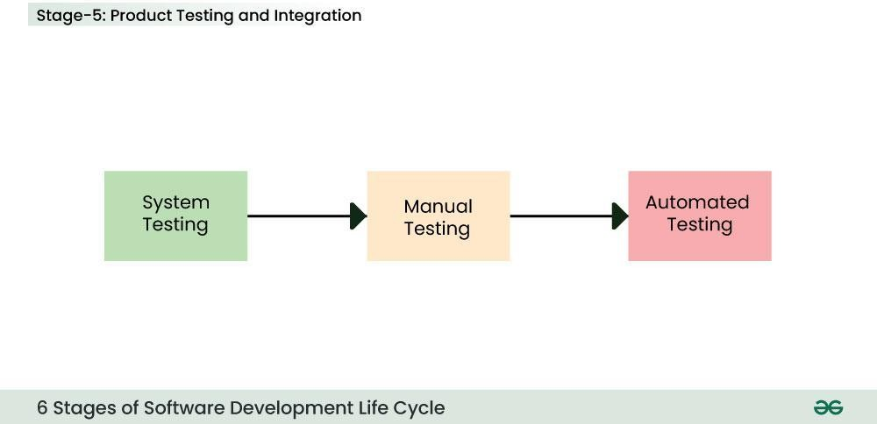
Stage-6: Deployment and Maintenance of Products
After detailed testing, the conclusive product is released in phases as per the organization’s strategy. Then it is tested in a real industrial environment. It is important to ensure its smooth performance. If it performs well, the organization sends out the product as a whole. After retrieving beneficial feedback, the company releases it as it is or with auxiliary improvements to make it further helpful for the customers. However, this alone is not enough. Therefore, along with the deployment, the product's supervision.

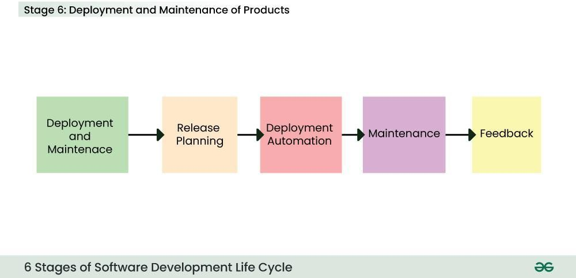
  - HARD REQUIRMENTS
Processor - Pentium –IV
RAM - 8 GB (min)
Hard Disk - 20 GB
Key Board - Standard Windows Keyboard Mouse - Two or Three Button Mouse Monitor - SVGA
  - SOFTWARE REQUIRMENTS
Operating system : Windows 7 Ultimate.
Coding Language : Python.
Front-End : Python.
Back-End : Django-ORM
Designing : Html, css, javascript.
Data Base : MySQL (WAMP Server).

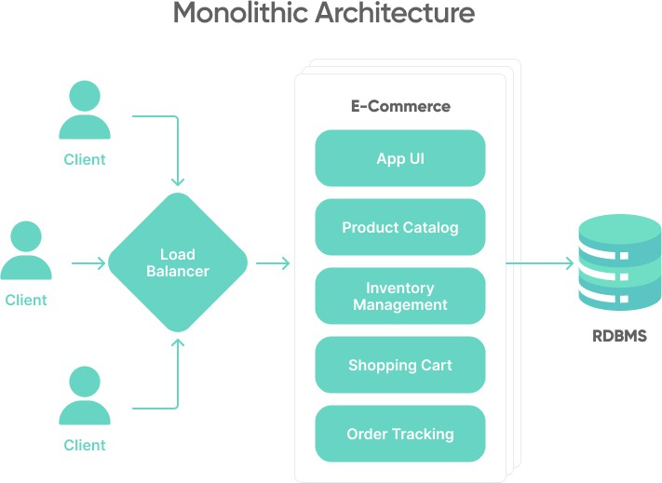
  - SYSTEM ARCHITECTURE

  - ULM DIAGRAMS UML DIAGRAMS

CHAPTER 4 SYSTEM DESIGN

UML stands for Unified Modeling Language. UML is a standardized general-purpose modeling language in the field of object-oriented software engineering. The standard is managed, and was created by, the Object Management Group.
The goal is for UML to become a common language for creating models of object oriented computer software. In its current form UML is comprised of two major components: a Meta- model and a notation. In the future, some form of method or process may also be added to; or associated with, UML.
The Unified Modeling Language is a standard language for specifying, Visualization, Constructing and documenting the artifacts of software system, as well as for business modeling and other non-software systems.

The UML represents a collection of best engineering practices that have proven successful in the modeling of large and complex systems.
The UML is a very important part of developing objects oriented software and the software development process. The UML uses mostly graphical notations to express the design of software projects.

GOALS:

The Primary goals in the design of the UML are as follows:
- Provide users a ready-to-use, expressive visual modeling Language so that they can develop and exchange meaningful models.
- Provide extendibility and specialization mechanisms to extend the core concepts.
- Be independent of particular programming languages and development process.
- Provide a formal basis for understanding the modeling language.
- Encourage the growth of OO tools market.
- Support higher level development concepts such as collaborations, frameworks, patterns and components.
- Integrate best practices.
- Bottom of Form

USE CASE DIAGRAM:
A use case diagram in the Unified Modeling Language (UML) is a type of behavioral diagram defined by and created from a Use-case analysis. Its purpose is to present a graphical overview of the functionality provided by a system in terms of actors, their goals (represented as use cases), and any dependencies between those use cases. The main purpose of a use case diagram is to show what system functions are performed for which actor. Roles of the actors in the system can be depicted.
VIEW USERS
VIEW CSRFS
ADMIN.
VIEW POST

VIEW GET

LOGOUT
GET CSRFS
MATCH PROCESS
USER.
MEACHINE LEARNING
LOGOUT

CLASS DIAGRAM:
In software engineering, a class diagram in the Unified Modeling Language (UML) is a type of static structure diagram that describes the structure of a system by showing the system's classes, their attributes, operations (or methods), and the relationships among the classes. It explains which class contains information.
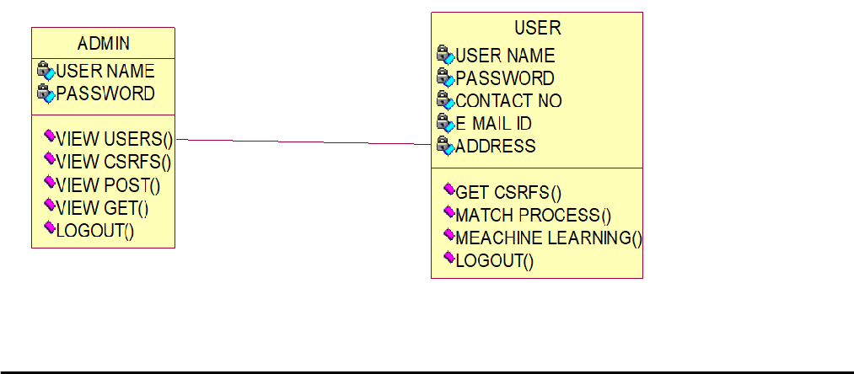

SEQUENCE DIAGRAM:
A sequence diagram in Unified Modeling Language (UML) is a kind of interaction diagram that shows how processes operate with one another and in what order. It is a construct of a Message Sequence Chart. Sequence diagrams are sometimes called event diagrams , event scenarios, and timing diagrams.
ADMIN
DATABASE
USER

VIEW USERS
GET CSRFS
VIEW CSRFS
MATCH PROCESS
VIEW POST
MEACHINE LEARNING
VIEW GET
LOGOUT
LOGOUT

    - ACTIVITY DIAGRAM :
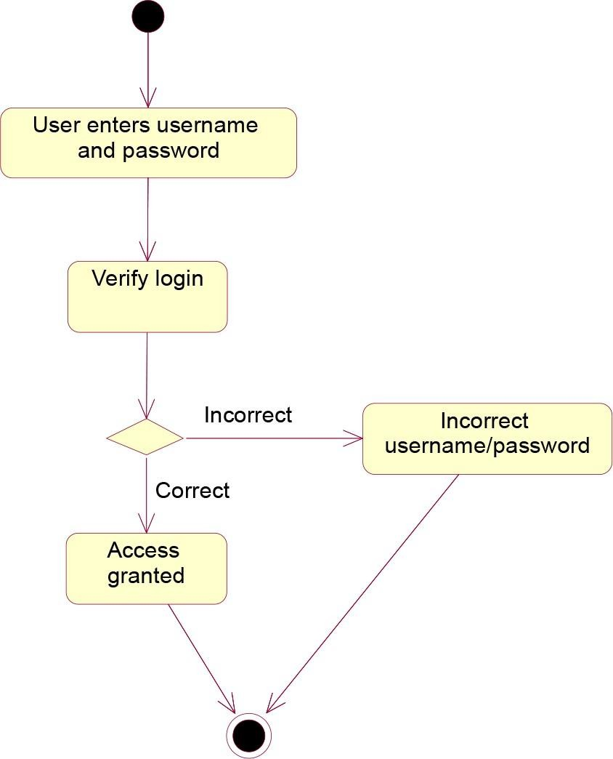

4.2.5 COLLRABATION DIAGRAM:

  - INPUT AND OUT PUT DESIGNS

INPUT DESIGN:
### Input Design:

- **Document Submission**: Users input the document(s) they wish to notarize into the system. This may involve uploading digital copies of the documents through a secure web interface or providing access to documents stored in cloud storage platforms.
- **National eID Card Authentication**: Users authenticate their identity using their National eID cards, which are equipped with digital signatures and biometric authentication features. This input ensures that only authorized individuals can access notarization services and submit documents for authentication.
- **Document Metadata**: Users may provide metadata associated with the document(s) being notarized, such as document title, description, purpose, and relevant timestamps. This metadata helps categorize and organize notarized documents within the system.

OUTPUT DESIGN:
- **Notarization Confirmation**: Upon successful authentication and verification, users receive a confirmation message indicating that their document(s) have been successfully notarized. This output assures users that their documents have been authenticated and added to the blockchain ledger.
- **Digitally Signed Notarization Certificate**: Users receive a digitally signed notarization certificate for each document notarized through the system. This certificate includes details such as the document hash, timestamp, notary public's digital signature, and blockchain transaction ID, providing irrefutable proof of notarization.
- **Blockchain Transaction ID**: Users receive a unique transaction ID associated with each notarization transaction recorded on the blockchain. This ID serves as a reference for verifying the authenticity and integrity of notarized documents on the blockchain ledger.
By designing a user-friendly input and output system for BANS, users can securely authenticate their documents using National eID cards and blockchain technology, ensuring the integrity, authenticity, and accessibility of notarized documents in the digital age.

  - SOFTWARE ENVIRONMENT

What is Python

Below are some facts about Python.

CHAPTER 5 IMPLEMENTATION

Python is currently the most widely used multi-purpose, high-level programming language.

Python allows programming in Object-Oriented and Procedural paradigms. Python programs generally are smaller than other programming languages like Java.
Programmers have to type relatively less and indentation requirement of the language, makes them readable all the time.
Python language is being used by almost all tech-giant companies like – Google, Amazon,
Facebook, Instagram, Dropbox, Uber… etc.

The biggest strength of Python is huge collection of standard library which can be used for the following .

Machine Learning

GUI Applications (like Kivy, Tkinter, PyQt etc. )

Web frameworks like Django (used by YouTube, Instagram, Dropbox) Image processing (like Opencv, Pillow)
Web scraping (like Scrapy, BeautifulSoup, Selenium) Test frameworks
Multimedia Advantages of Python :-
Let’s see how Python dominates over other languages.

- Extensive Libraries

Python downloads with an extensive library and it contain code for various purposes like regular expressions, documentation-generation, unit-testing, web browsers, threading, databases, CGI, email, image manipulation, and more. So, we don’t have to write the complete code for that manually.
- Extensible

As we have seen earlier, Python can be extended to other languages. You can write some of your code in languages like C++ or C. This comes in handy, especially in projects.
- Embeddable

Complimentary to extensibility, Python is embeddable as well. You can put your Python code in your source code of a different language, like C++. This lets us add scripting capabilities to our code in the other language.
- Improved Productivity

The language’s simplicity and extensive libraries render programmers more productive than languages like Java and C++ do. Also, the fact that you need to write less and get more things done.
- IOT Opportunities

Since Python forms the basis of new platforms like Raspberry Pi, it finds the future bright for the Internet Of Things. This is a way to connect the language with the real world.
- Simple and Easy

When working with Java, you may have to create a class to print ‘Hello World’. But in Python, just a print statement will do. It is also quite easy to learn, understand, and code. This is why when people pick up Python, they have a hard time adjusting to other more verbose languages like Java.
- Readable

Because it is not such a verbose language, reading Python is much like reading English. This is the reason why it is so easy to learn, understand, and code. It also does not need curly braces to define blocks, and indentation is mandatory. This further aids the readability of the code.
- Object-Oriented

This language supports both the procedural and object-oriented programming paradigms. While functions help us with code reusability, classes and objects let us model the real world. A class allows the encapsulation of data and functions into one.

- Free and Open-Source

Like we said earlier, Python is freely available. But not only can you download Python for free, but you can also download its source code, make changes to it, and even distribute it. It downloads with an extensive collection of libraries to help you with your tasks.
- Portable

When you code your project in a language like C++, you may need to make some changes to it if you want to run it on another platform. But it isn’t the same with Python. Here, you need to code only once, and you can run it anywhere. This is called Write Once Run Anywhere (WORA). However, you need to be careful enough not to include any system-dependent features.
- Interpreted

Lastly, we will say that it is an interpreted language. Since statements are executed one by one, debugging is easier than in compiled languages.
Any doubts till now in the advantages of Python? Mention in the comment section.

Advantages of Python Over Other Languages
- Less Coding
Almost all of the tasks done in Python requires less coding when the same task is done in other languages. Python also has an awesome standard library support, so you don’t have to search for any third-party libraries to get your job done. This is the reason that many people suggest learning Python to beginners.
- Affordable

Python is free therefore individuals, small companies or big organizations can leverage the free available resources to build applications. Python is popular and widely used so it gives you better community support.
The 2019 Github annual survey showed us that Python has overtaken Java in the most popular programming language category.
- Python is for Everyone

Python code can run on any machine whether it is Linux, Mac or Windows. Programmers need to learn different languages for different jobs but with Python, you can professionally build web apps, perform data analysis and machine learning, automate things, do web scraping and also build games and powerful visualizations. It is an all-rounder programming language.

Disadvantages of Python

So far, we’ve seen why Python is a great choice for your project. But if you choose it, you should be aware of its consequences as well. Let’s now see the downsides of choosing Python over another language.

Speed Limitations

We have seen that Python code is executed line by line. But since Python is interpreted, it often results in slow execution. This, however, isn’t a problem unless speed is a focal point for the project. In other words, unless high speed is a requirement, the benefits offered by Python are enough to distract us from its speed limitations.

Weak in Mobile Computing and Browsers

While it serves as an excellent server-side language, Python is much rarely seen on the client- side. Besides that, it is rarely ever used to implement smartphone-based applications. One such application is called Carbonnelle.
The reason it is not so famous despite the existence of Brython is that it isn’t that secure.

Design Restrictions

As you know, Python is dynamically-typed. This means that you don’t need to declare the type of variable while writing the code. It uses duck-typing. But wait, what’s that? Well, it just means that if it looks like a duck, it must be a duck. While this is easy on the programmers during coding, it can raise run-time errors.

Underdeveloped Database Access Layers

Compared to more widely used technologies like JDBC (Java DataBase Connectivity) and ODBC (Open DataBase Connectivity), Python’s database access layers are a bit underdeveloped. Consequently, it is less often applied in huge enterprises.

Simple

No, we’re not kidding. Python’s simplicity can indeed be a problem. Take my example. I don’t do Java, I’m more of a Python person. To me, its syntax is so simple that the verbosity of Java code seems unnecessary.
This was all about the Advantages and Disadvantages of Python Programming Language.

History of Python

What do the alphabet and the programming language Python have in common? Right, both start with ABC. If we are talking about ABC in the Python context, it's clear that the programming language ABC is meant. ABC is a general-purpose programming language and programming environment, which had been developed in the Netherlands, Amsterdam, at the CWI (Centrum Wiskunde &Informatica). The greatest achievement of ABC was to influence the design of Python.Python was conceptualized in the late 1980s. Guido van Rossum worked that time in a project at the CWI, called Amoeba, a distributed operating system. In an interview with Bill Venners¹, Guido van Rossum said: "In the early 1980s, I worked as an implementer on a team building a language called ABC at Centrum voor Wiskunde en Informatica (CWI).
I don't know how well people know ABC's influence on Python. I try to mention ABC's influence because I'm indebted to everything I learned during that project and to the people who worked on it."Later on in the same Interview, Guido van Rossum continued: "I remembered all my experience and some of my frustration with ABC. I decided to try to design a simple scripting language that possessed some of ABC's better properties, but without its problems. So I started typing. I created a simple virtual machine, a simple parser, and a simple runtime. I made my own version of the various ABC parts that I liked. I created a basic syntax, used indentation for statement grouping instead of curly braces or begin-end blocks, and developed a small number of powerful data types: a hash table (or dictionary, as we call it), a list, strings, and numbers."

What is Machine Learning : -

Before we take a look at the details of various machine learning methods, let's start by looking at what machine learning is, and what it isn't. Machine learning is often categorized as a subfield of artificial intelligence, but I find that categorization can often be misleading at first brush. The study of machine learning certainly arose from research in this context, but in the data science application of machine learning methods, it's more helpful to think of machine learning as a means of building models of data.
Fundamentally, machine learning involves building mathematical models to help understand data. "Learning" enters the fray when we give these models tunable parameters that can be adapted to observed data; in this way the program can be considered to be "learning" from the data.

Once these models have been fit to previously seen data, they can be used to predict and understand aspects of newly observed data. I'll leave to the reader the more philosophical digression regarding the extent to which this type of mathematical, model-based "learning" is similar to the "learning" exhibited by the human brain.Understanding the problem setting in machine learning is essential to using these tools effectively, and so we will start with some broad categorizations of the types of approaches we'll discuss here.

Categories Of Machine Leaning :-

At the most fundamental level, machine learning can be categorized into two main types: supervised learning and unsupervised learning.
Supervised learning involves somehow modeling the relationship between measured features of data and some label associated with the data; once this model is determined, it can be used to apply labels to new, unknown data. This is further subdivided into classification tasks and regression tasks: in classification, the labels are discrete categories, while in regression, the labels are continuous quantities. We will see examples of both types of supervised learning in the following section.
Unsupervised learning involves modeling the features of a dataset without reference to any label, and is often described as "letting the dataset speak for itself." These models include tasks such as clustering and dimensionality reduction. Clustering algorithms identify distinct groups of data, while dimensionality reduction algorithms search for more succinct representations of the data. We will see examples of both types of unsupervised learning in the following section.

Need for Machine Learning

Human beings, at this moment, are the most intelligent and advanced species on earth because they can think, evaluate and solve complex problems. On the other side, AI is still in its initial stage and haven’t surpassed human intelligence in many aspects. Then the question is that what is the need to make machine learn? The most suitable reason for doing this is, “to make decisions, based on data, with efficiency and scale”.
Lately, organizations are investing heavily in newer technologies like Artificial Intelligence, Machine Learning and Deep Learning to get the key information from data to perform several real-world tasks and solve problems. We can call it data-driven decisions taken by machines, particularly to automate the process. These data-driven decisions can be used, instead of using

programing logic, in the problems that cannot be programmed inherently. The fact is that we can’t do without human intelligence, but other aspect is that we all need to solve real-world problems with efficiency at a huge scale. That is why the need for machine learning arises.
Challenges in Machines Learning :-While Machine Learning is rapidly evolving, making significant strides with cybersecurity and autonomous cars, this segment of AI as whole still has a long way to go. The reason behind is that ML has not been able to overcome number of challenges. The challenges that ML is facing currently are Quality of data − Having good- quality data for ML algorithms is one of the biggest challenges. Use of low-quality data leads to the problems related to data preprocessing and feature extraction.
Time-Consuming task − Another challenge faced by ML models is the consumption of time
especially for data acquisition, feature extraction and retrieval.

Lack of specialist persons − As ML technology is still in its infancy stage, availability of
expert resources is a tough job.

No clear objective for formulating business problems − Having no clear objective and well- defined goal for business problems is another key challenge for ML because this technology is not that mature yet.
Issue of overfitting & underfitting − If the model is overfitting or underfitting, it cannot be
represented well for the problem.

Curse of dimensionality − Another challenge ML model faces is too many features of data
points. This can be a real hindrance.

Difficulty in deployment − Complexity of the ML model makes it quite difficult to be
deployed in real life.

Applications of Machines Learning :-

Machine Learning is the most rapidly growing technology and according to researchers we are in the golden year of AI and ML. It is used to solve many real-world complex problems which cannot be solved with traditional approach. Following are some real-world applications of ML
Emotion analysis Sentiment analysis

Error detection and prevention Weather forecasting and prediction Stock market analysis and forecasting Speech synthesis
Speech recognition Customer segmentation Object recognition Fraud detection
Fraud prevention

Recommendation of products to customer in online shopping

How to Start Learning Machine Learning?

Arthur Samuel coined the term “Machine Learning” in 1959 and defined it as a “Field of study that gives computers the capability to learn without being explicitly programmed”.
And that was the beginning of Machine Learning! In modern times, Machine Learning is one of the most popular (if not the most!) career choices. According to Indeed, Machine Learning Engineer Is The Best Job of 2019 with a 344% growth and an average base salary of $146,085 per year.
But there is still a lot of doubt about what exactly is Machine Learning and how to start learning it? So this article deals with the Basics of Machine Learning and also the path you can follow to eventually become a full-fledged Machine Learning Engineer. Now let’s get started!!!

How to start learning ML?

This is a rough roadmap you can follow on your way to becoming an insanely talented Machine Learning Engineer. Of course, you can always modify the steps according to your needs to reach your desired end-goal!

Step 1 – Understand the Prerequisites

In case you are a genius, you could start ML directly but normally, there are some prerequisites that you need to know which include Linear Algebra, Multivariate Calculus, Statistics, and Python. And if you don’t know these, never fear! You don’t need a Ph.D. degree in these topics to get started but you do need a basic understanding.

Learn Linear Algebra and Multivariate Calculus

Both Linear Algebra and Multivariate Calculus are important in Machine Learning. However, the extent to which you need them depends on your role as a data scientist. If you are more focused on application heavy machine learning, then you will not be that heavily focused on maths as there are many common libraries available. But if you want to focus on R&D in Machine Learning, then mastery of Linear Algebra and Multivariate Calculus is very important as you will have to implement many ML algorithms from scratch.

Learn Statistics

Data plays a huge role in Machine Learning. In fact, around 80% of your time as an ML expert will be spent collecting and cleaning data. And statistics is a field that handles the collection, analysis, and presentation of data. So it is no surprise that you need to learn it!!! Some of the key concepts in statistics that are important are Statistical Significance, Probability Distributions, Hypothesis Testing, Regression, etc. Also, Bayesian Thinking is also a very important part of ML which deals with various concepts like Conditional Probability, Priors, and Posteriors, Maximum Likelihood, etc.

Learn Python

Some people prefer to skip Linear Algebra, Multivariate Calculus and Statistics and learn them as they go along with trial and error. But the one thing that you absolutely cannot skip is Python! While there are other languages you can use for Machine Learning like R, Scala, etc. Python is currently the most popular language for ML. In fact, there are many Python libraries that are specifically useful for Artificial Intelligence and Machine Learning such as Keras, TensorFlow, Scikit-learn, etc.
So if you want to learn ML, it’s best if you learn Python! You can do that using various online
resources and courses such as Fork Python available Free on GeeksforGeeks.

Step 2 – Learn Various ML Concepts

Now that you are done with the prerequisites, you can move on to actually learning ML (Which is the fun part!!!) It’s best to start with the basics and then move on to the more complicated stuff. Some of the basic concepts in ML are:

Terminologies of Machine Learning

Model – A model is a specific representation learned from data by applying some machine learning algorithm. A model is also called a hypothesis.
Feature – A feature is an individual measurable property of the data. A set of numeric features can be conveniently described by a feature vector. Feature vectors are fed as input to the model. For example, in order to predict a fruit, there may be features like col or, smell, taste, etc.
Target (Label) – A target variable or label is the value to be predicted by our model. For the fruit example discussed in the feature section, the label with each set of input would be the name of the fruit like apple, orange, banana, etc.
Training – The idea is to give a set of inputs(features) and it’s expected outputs(labels), so after training, we will have a model (hypothesis) that will then map new data to one of the categories trained on.
Prediction – Once our model is ready, it can be fed a set of inputs to which it will provide a predicted output(label).
- Types of Machine Learning

Supervised Learning – This involves learning from a training dataset with labeled data using classification and regression models. This learning process continues until the required level of performance is achieved.
Unsupervised Learning – This involves using unlabelled data and then finding the underlying structure in the data in order to learn more and more about the data itself using factor and cluster analysis models.
Semi-supervised Learning – This involves using unlabelled data like Unsupervised Learning with a small amount of labeled data. Using labeled data vastly increases the learning accuracy and is also more cost-effective than Supervised Learning.

Reinforcement Learning – This involves learning optimal actions through trial and error. So the next action is decided by learning behaviors that are based on the current state and that will maximize the reward in the future.

Advantages of Machine learning :-

- Easily identifies trends and patterns -

Machine Learning can review large volumes of data and discover specific trends and patterns that would not be apparent to humans. For instance, for an e-commerce website like Amazon, it serves to understand the browsing behaviors and purchase histories of its users to help cater to the right products, deals, and reminders relevant to them. It uses the results to reveal relevant advertisements to them.
- No human intervention needed (automation)

With ML, you don’t need to babysit your project every step of the way. Since it means giving machines the ability to learn, it lets them make predictions and also improve the algorithms on their own. A common example of this is anti-virus softwares; they learn to filter new threats as they are recognized. ML is also good at recognizing spam.
- Continuous Improvement

As ML algorithms gain experience, they keep improving in accuracy and efficiency. This lets them make better decisions. Say you need to make a weather forecast model. As the amount of data you have keeps growing, your algorithms learn to make more accurate predictions faster.
- Handling multi-dimensional and multi-variety data

Machine Learning algorithms are good at handling data that are multi-dimensional and multi- variety, and they can do this in dynamic or uncertain environments.
- Wide Applications

You could be an e-tailer or a healthcare provider and make ML work for you. Where it does apply, it holds the capability to help deliver a much more personal experience to customers while also targeting the right customers.

Disadvantages of Machine Learning :-

- Data Acquisition

Machine Learning requires massivedata sets to train on, and these should be inclusive/unbiased, and of good quality. There can also be times where they must wait for new data to be generated.
- Time and Resources

ML needs enough time to let the algorithms learn and develop enough to fulfill their purpose with a considerable amount of accuracy and relevancy. It also needs massive resources to function. This can mean additional requirements of computer power for you.
- Interpretation of Results

Another major challenge is the ability to accurately interpret results generated by the algorithms. You must also carefully choose the algorithms for your purpose.
- High error-susceptibility

Machine Learning is autonomous but highly susceptible to errors. Suppose you train an algorithm with data sets small enough to not be inclusive. You end up with biased predictions coming from a biased training set. This leads to irrelevant advertisements being displayed to customers. In the case of ML, such blunders can set off a chain of errors that can go undetected for long periods of time. And when they do get noticed, it takes quite some time to recognize the source of the issue, and even longer to correct it.

Python Development Steps : -

Guido Van Rossum published the first version of Python code (version 0.9.0) at alt.sources in February 1991. This release included already exception handling, functions, and the core data types of list, dict, str and others. It was also object oriented and had a module system. Python version 1.0 was released in January 1994. The major new features included in this release were the functional programming tools lambda, map, filter and reduce, which Guido Van Rossum never liked.Six and a half years later in October 2000, Python 2.0 was introduced. This release included list comprehensions, a full garbage collector and it was supporting unicode.Python flourished for another 8 years in the versions 2.x before the next major release

as Python 3.0 (also known as "Python 3000" and "Py3K") was released. Python 3 is not backwards compatible with Python 2.x.
The emphasis in Python 3 had been on the removal of duplicate programming constructs and modules, thus fulfilling or coming close to fulfilling the 13th law of the Zen of Python: "There should be one -- and preferably only one -- obvious way to do it."Some changes in Python 7.3:

Print is now a function

Views and iterators instead of lists

The rules for ordering comparisons have been simplified. E.g. a heterogeneous list cannot be sorted, because all the elements of a list must be comparable to each other.
There is only one integer type left, i.e. int. long is int as well.

The division of two integers returns a float instead of an integer. "//" can be used to have the "old" behaviour.
Text Vs. Data Instead Of Unicode Vs. 8-bit

Purpose :-

We demonstrated that our approach enables successful segmentation of intra-retinal layers— even with low-quality images containing speckle noise, low contrast, and different intensity ranges throughout—with the assistance of the ANIS feature.

Python

Python is an interpreted high-level programming language for general-purpose programming. Created by Guido van Rossum and first released in 1991, Python has a design philosophy that emphasizes code readability, notably using significant whitespace.
Python features a dynamic type system and automatic memory management. It supports multiple programming paradigms, including object-oriented, imperative, functional and procedural, and has a large and comprehensive standard library.
Python is Interpreted − Python is processed at runtime by the interpreter. You do not need to
compile your program before executing it. This is similar to PERL and PHP.

Python is Interactive − you can actually sit at a Python prompt and interact with the interpreter
directly to write your programs.

Python also acknowledges that speed of development is important. Readable and terse code is part of this, and so is access to powerful constructs that avoid tedious repetition of code. Maintainability also ties into this may be an all but useless metric, but it does say something about how much code you have to scan, read and/or understand to troubleshoot problems or tweak behaviors. This speed of development, the ease with which a programmer of other languages can pick up basic Python skills and the huge standard library is key to another area where Python excels. All its tools have been quick to implement, saved a lot of time, and several of them have later been patched and updated by people with no Python background - without breaking.

Modules Used in Project :- Tensorflow
TensorFlow is a free and open-source software library for dataflow and differentiable programming across a range of tasks. It is a symbolic math library, and is also used for machine learning applications such as neural networks. It is used for both research and production at Google.
TensorFlow was developed by the Google Brain team for internal Google use. It was released under the Apache 2.0 open-source license on November 9, 2015.

Numpy

Numpy is a general-purpose array-processing package. It provides a high-performance multidimensional array object, and tools for working with these arrays.
It is the fundamental package for scientific computing with Python. It contains various features including these important ones:
A powerful N-dimensional array object Sophisticated (broadcasting) functions
Tools for integrating C/C++ and Fortran code

Useful linear algebra, Fourier transform, and random number capabilities

Besides its obvious scientific uses, Numpy can also be used as an efficient multi-dimensional container of generic data. Arbitrary data-types can be defined using Numpy which allows Numpy to seamlessly and speedily integrate with a wide variety of databases.

Pandas

Pandas is an open-source Python Library providing high-performance data manipulation and analysis tool using its powerful data structures. Python was majorly used for data munging and preparation. It had very little contribution towards data analysis. Pandas solved this problem. Using Pandas, we can accomplish five typical steps in the processing and analysis of data, regardless of the origin of data load, prepare, manipulate, model, and analyze. Python with Pandas is used in a wide range of fields including academic and commercial domains including finance, economics, Statistics, analytics, etc.

Matplotlib

Matplotlib is a Python 2D plotting library which produces publication quality figures in a variety of hardcopy formats and interactive environments across platforms. Matplotlib can be used in Python scripts, the Python and IPython shells, the Jupyter Notebook, web application servers, and four graphical user interface toolkits. Matplotlib tries to make easy things easy and hard things possible. You can generate plots, histograms, power spectra, bar charts, error charts, scatter plots, etc., with just a few lines of code. For examples, see the sample plots and thumbnail gallery.
For simple plotting the pyplot module provides a MATLAB-like interface, particularly when combined with IPython. For the power user, you have full control of line styles, font properties, axes properties, etc, via an object oriented interface or via a set of functions familiar to MATLAB users.

Scikit – learn

Scikit-learn provides a range of supervised and unsupervised learning algorithms via a consistent interface in Python. It is licensed under a permissive simplified BSD license and is distributed under many Linux distributions, encouraging academic and commercial use.

Python

Python is an interpreted high-level programming language for general-purpose programming. Created by Guido van Rossum and first released in 1991, Python has a design philosophy that emphasizes code readability, notably using significant whitespace.
Python features a dynamic type system and automatic memory management. It supports multiple programming paradigms, including object-oriented, imperative, functional and procedural, and has a large and comprehensive standard library.
Python is Interpreted − Python is processed at runtime by the interpreter. You do not need to
compile your program before executing it. This is similar to PERL and PHP.

Python is Interactive − you can actually sit at a Python prompt and interact with the interpreter
directly to write your programs.

Python also acknowledges that speed of development is important. Readable and terse code is part of this, and so is access to powerful constructs that avoid tedious repetition of code. Maintainability also ties into this may be an all but useless metric, but it does say something about how much code you have to scan, read and/or understand to troubleshoot problems or tweak behaviors. This speed of development, the ease with which a programmer of other languages can pick up basic Python skills and the huge standard library is key to another area where Python excels.
All its tools have been quick to implement, saved a lot of time, and several of them have later been patched and updated by people with no Python background - without breaking.

Install Python Step-by-Step in Windows and Mac :

Python a versatile programming language doesn’t come pre-installed on your computer devices. Python was first released in the year 1991 and until today it is a very popular high-level programming language. Its style philosophy emphasizes code readability with its notable use of great whitespace.
The object-oriented approach and language construct provided by Python enables programmers to write both clear and logical code for projects. This software does not come pre-packaged with Windows.

How to Install Python on Windows and Mac :

There have been several updates in the Python version over the years. The question is how to install Python? It might be confusing for the beginner who is willing to start learning Python but this tutorial will solve your query. The latest or the newest version of Python is version 3.7.4 or in other words, it is Python 3.
Note: The python version 3.7.4 cannot be used on Windows XP or earlier devices.

Before you start with the installation process of Python. First, you need to know about your System Requirements. Based on your system type i.e. operating system and based processor, you must download the python version. My system type is a Windows 64-bit operating system. So the steps below are to install python version 3.7.4 on Windows 7 device or to install Python 3. Download the Python Cheatsheet here.The steps on how to install Python on Windows 10, 8 and 7 are divided into 4 parts to help understand better.
Download the Correct version into the system

Step 1: Go to the official site to download and install python using Google Chrome or any other web browser. OR Click on the following link: https://www.python.org
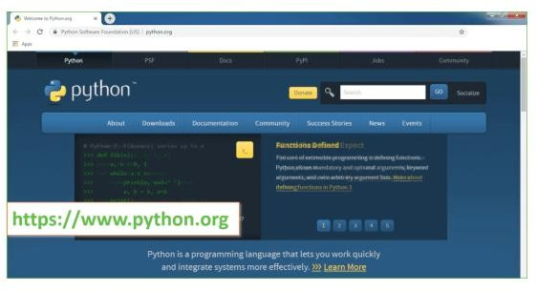

Now, check for the latest and the correct version for your operating system.

Step 2: Click on the Download Tab.

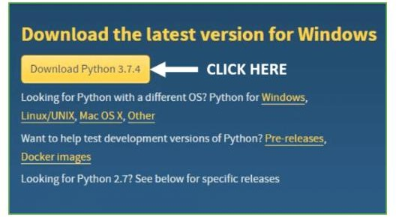

Step 3: You can either select the Download Python for windows 3.7.4 button in Yellow Color or you can scroll further down and click on download with respective to their version. Here, we are downloading the most recent python version for windows 3.7.4
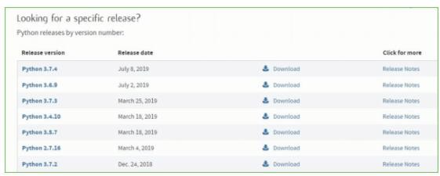

Step 4: Scroll down the page until you find the Files option.

Step 5: Here you see a different version of python along with the operating system.

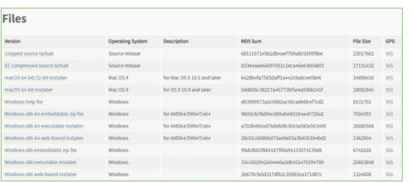

- To download Windows 32-bit python, you can select any one from the three options: Windows x86 embeddable zip file, Windows x86 executable installer or Windows x86 web-based installer.
- To download Windows 64-bit python, you can select any one from the three options: Windows x86-64 embeddable zip file, Windows x86-64 executable installer or Windows x86-64 web-based installer.
Here we will install Windows x86-64 web-based installer. Here your first part regarding which version of python is to be downloaded is completed. Now we move ahead with the second part in installing python
i.e. Installation

Note: To know the changes or updates that are made in the version you can click on the Release Note Option.

Installation of Python

Step 1: Go to Download and Open the downloaded python version to carry out the installation process.
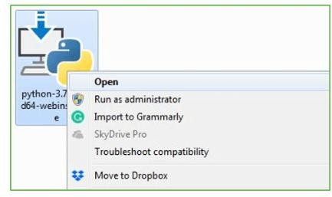

Step 2: Before you click on Install Now, Make sure to put a tick on Add Python 3.7 to PATH.
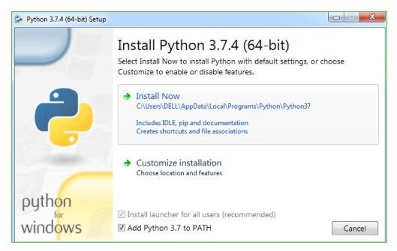

Step 3: Click on Install NOW After the installation is successful. Click on Close.
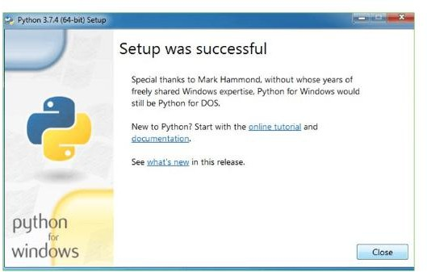

With these above three steps on python installation, you have successfully and correctly installed Python. Now is the time to verify the installation.
Note: The installation process might take a couple of minutes. Verify the Python Installation
Step 1: Click on Start

Step 2: In the Windows Run Command, type “cmd”.
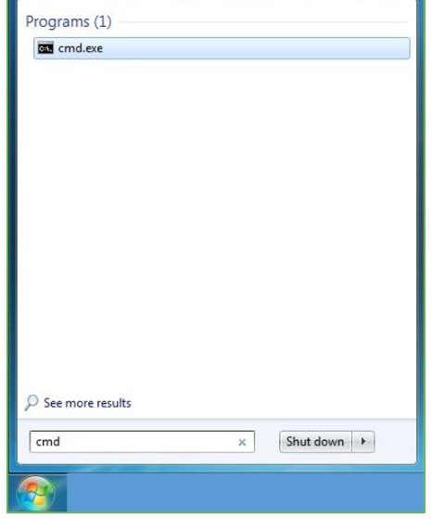

Step 3: Open the Command prompt option.

Step 4: Let us test whether the python is correctly installed. Type python –V and press Enter.
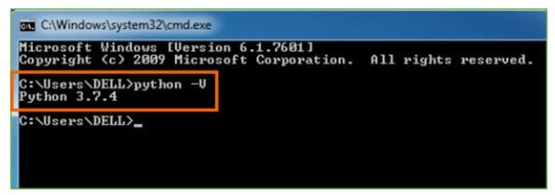

Step 5: You will get the answer as 3.7.4

Note: If you have any of the earlier versions of Python already installed. You must first uninstall the earlier version and then install the new one.
Check how the Python IDLE works

Step 1: Click on Start

Step 2: In the Windows Run command, type “python idle”.
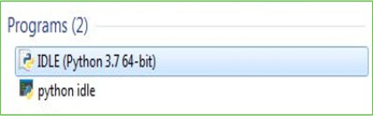

Step 3: Click on IDLE (Python 3.7 64-bit) and launch the program

Step 4: To go ahead with working in IDLE you must first save the file. Click on File > Click on Save
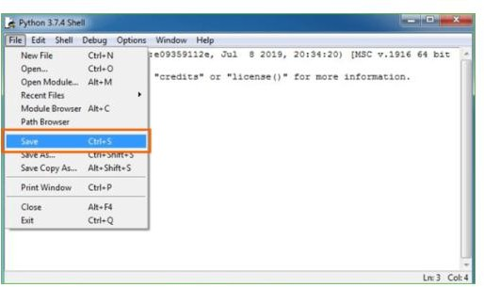

Step 5: Name the file and save as type should be Python files. Click on SAVE. Here I have named the files as Hey World.
Step 6: Now for e.g. enter print

Sample code

# Importing Libraries
import numpy as np # For numerical operations import pandas as pd # For handling datasets import matplotlib.pyplot as plt # For plotting graphs import seaborn as sns # For heatmaps
import pickle # For saving/loading models from sklearn.model_selection import train_test_split
from sklearn.feature_extraction.text import TfidfVectorizer from sklearn import svm
from lightgbm import LGBMClassifier
from sklearn.metrics import accuracy_score, precision_score, recall_score, f1_score, confusion_matrix
# Step 1: Load Dataset
# Benign URLs (normal) and Phishing URLs (malicious) benign = pd.read_csv("1.Benign_list_big_final.csv") phish = pd.read_csv("2.online-valid.csv")
# Assign class labels: 0 = Normal, 1 = Phishing benign['label'] = 0
phish['label'] = 1
# Combine into single dataset data = pd.concat([benign, phish])
data = data.sample(frac=1).reset_index(drop=True) # shuffle print("Dataset size:", data.shape)
print(data.head())
# Step 2: Feature Extraction using TF-IDF tfidf = TfidfVectorizer()
X = tfidf.fit_transform(data['url'].astype(str)).toarray() Y = data['label'].values

# Split into training and test sets
X_train, X_test, y_train, y_test = train_test_split( X, Y, test_size=0.2, random_state=42, stratify=Y
)
# Step 3: Train Machine Learning Models # Support Vector Machine (SVM) svm_model = svm.SVC() svm_model.fit(X_train, y_train)
# LightGBM Classifier lgbm_model = LGBMClassifier()
lgbm_model.fit(X_train, y_train)# Save models for reuse pickle.dump(tfidf, open("tfidf.pkl", "wb")) pickle.dump(svm_model, open("svm.pkl", "wb")) pickle.dump(lgbm_model, open("lgbm.pkl", "wb"))
# Step 4: Evaluate Models
def evaluate(model, X_test, y_test, name): y_pred = model.predict(X_test)
acc = accuracy_score(y_test, y_pred) * 100
pre = precision_score(y_test, y_pred, average='macro') * 100 rec = recall_score(y_test, y_pred, average='macro') * 100
f1 = f1_score(y_test, y_pred, average='macro') * 100 print(f"{name} Results:")
print("Accuracy :", acc) print("Precision:", pre) print("Recall :", rec) print("F1 Score :", f1)
# Confusion Matrix Heatmap
cm = confusion_matrix(y_test, y_pred) plt.figure(figsize=(5,5))

sns.heatmap(cm, annot=True, fmt="d", cmap="Blues", xticklabels=['Normal','Phishing'], yticklabels=['Normal','Phishing'])
plt.title(f"{name} Confusion Matrix") plt.xlabel("Predicted") plt.ylabel("True")
plt.show()
# Evaluate both models evaluate(svm_model, X_test, y_test, "SVM")
evaluate(lgbm_model, X_test, y_test, "LightGBM") # Step 5: Predict New URL
def predict_url(url):
text = " ".join([p for p in url.split("/") if p.strip()]) features = tfidf.transform([text]).toarray()
result = lgbm_model.predict(features)[0] if result == 0:
print(url, " -> Genuine Website") else:
print(url, " -> !!! Phishing Detected !!!") # Example predictions predict_url("https://mail.google.com")
predict_url("http://malicious.fakebank.com/login")

  - TYPES OF TESTS

CHAPTER 6 SYSTEM TESTING

Unit testing
Unit testing involves the design of test cases that validate that the internal program logic is functioning properly, and that program inputs produce valid outputs. All decision branches and internal code flow should be validated. It is the testing of individual software units of the application .it is done after the completion of an individual unit before integration. This is a structural testing, that relies on knowledge of its construction and is invasive. Unit tests perform basic tests at component level and test a specific business process, application, and/or system configuration. Unit tests ensure that each unique path of a business process performs accurately to the documented specifications and contains clearly defined inputs and expected results.

Integration testing

Integration tests are designed to test integrated software components to determine if they actually run as one program. Testing is event driven and is more concerned with the basic outcome of screens or fields. Integration tests demonstrate that although the components were individually satisfaction, as shown by successfully unit testing, the combination of components is correct and consistent. Integration testing is specifically aimed at exposing the problems that arise from the combination of components.

Functional test

Functional tests provide systematic demonstrations that functions tested are available as specified by the business and technical requirements, system documentation, and user manuals.
Functional testing is centered on the following items:

Valid Input : identified classes of valid input must be accepted. Invalid Input : identified classes of invalid input must be rejected. Functions : identified functions must be exercised.
Output : identified classes of application outputs must be exercised.

Systems/Procedures : interfacing systems or procedures must be invoked Organization and preparation of functional tests is focused on requirements, key functions, or special test cases. In addition, systematic coverage pertaining to identify Business process flows; data fields, predefined processes, and successive processes must be considered for testing. Before functional testing is complete, additional tests are identified and the effective value of current tests is determined.

System Test

System testing ensures that the entire integrated software system meets requirements. It tests a configuration to ensure known and predictable results. An example of system testing is the configuration oriented system integration test. System testing is based on process descriptions and flows, emphasizing pre-driven process links and integration points.

White Box Testing

White Box Testing is a testing in which in which the software tester has knowledge of the inner workings, structure and language of the software, or at least its purpose. It is purpose. It is used to test areas that cannot be reached from a black box level.

Black Box Testing

Black Box Testing is testing the software without any knowledge of the inner workings, structure or language of the module being tested. Black box tests, as most other kinds of tests, must be written from a definitive source document, such as specification or requirements document, such as specification or requirements document. It is a testing in which the software under test is treated, as a black box .you cannot “see” into it. The test provides inputs and responds to outputs without considering how the software works.

Unit Testing

Unit testing is usually conducted as part of a combined code and unit test phase of the software lifecycle, although it is not uncommon for coding and unit testing to be conducted as two distinct phases.

Test strategy and approach

Field testing will be performed manually and functional tests will be written in
detail.

Test objectives

All field entries must work properly.

Pages must be activated from the identified link.

The entry screen, messages and responses must not be delayed.

Features to be tested

Verify that the entries are of the correct format No duplicate entries should be allowed
All links should take the user to the correct page. Integration Testing
Software integration testing is the incremental integration testing of two or more integrated software components on a single platform to produce failures caused by interface defects.
The task of the integration test is to check that components or software applications, e.g. components in a software system or – one step up – software applications at the company level – interact without error.
Test Results:All the test cases mentioned above passed successfully. No defects encountered.

Acceptance Testing

User Acceptance Testing is a critical phase of any project and requires significant participation by the end user. It also ensures that the system meets the functional requirements.
Test Results:All the test cases mentioned above passed successfully. No defects encountered.

The purpose of testing is to discover errors. Testing is the process of trying to discover every conceivable fault or weakness in a work product. It provides a way to check the functionality of components, sub assemblies, assemblies and/or a finished product It is the process of exercising software with the intent of ensuring that the Software system meets its requirements and user expectations and does not fail in an unacceptable manner. There are various types of test. Each test type addresses a specific testing requirement.

  - TYPES OF TESTS

Unit testing

Unit testing involves the design of test cases that validate that the internal program logic is functioning properly, and that program inputs produce valid outputs. All decision branches and internal code flow should be validated. It is the testing of individual software units of the application .it is done after the completion of an individual unit before integration. This is a structural testing, that relies on knowledge of its construction and is invasive. Unit tests perform basic tests at component level and test a specific business process, application, and/or system configuration. Unit tests ensure that each unique path of a business process performs accurately to the documented specifications and contains clearly defined inputs and expected results.

Integration testing

Integration tests are designed to test integrated software components to determine if they actually run as one program. Testing is event driven and is more concerned with the basic outcome of screens or fields. Integration tests demonstrate that although the components were individually satisfaction, as shown by successfully unit testing, the combination of components is correct and consistent. Integration testing is specifically aimed at exposing the problems that arise from the combination of components.

Functional test

Functional tests provide systematic demonstrations that functions tested are available as specified by the business and technical requirements, system documentation, and user manuals.

Functional testing is centered on the following items:

Valid Input : identified classes of valid input must be accepted. Invalid Input : identified classes of invalid input must be rejected. Functions : identified functions must be exercised.
Output : identified classes of application outputs must be exercised.

Systems/Procedures : interfacing systems or procedures must be invoked Organization and preparation of functional tests is focused on requirements, key functions, or special test cases. In addition, systematic coverage pertaining to identify Business process flows; data fields, predefined processes, and successive processes must be considered for testing. Before functional testing is complete, additional tests are identified and the effective value of current tests is determined.

System Test

System testing ensures that the entire integrated software system meets requirements. It tests a configuration to ensure known and predictable results. An example of system testing is the configuration oriented system integration test. System testing is based on process descriptions and flows, emphasizing pre-driven process links and integration points.

White Box Testing

White Box Testing is a testing in which in which the software tester has knowledge of the inner workings, structure and language of the software, or at least its purpose. It is purpose. It is used to test areas that cannot be reached from a black box level.

Black Box Testing

Black Box Testing is testing the software without any knowledge of the inner workings, structure or language of the module being tested. Black box tests, as most other kinds of tests, must be written from a definitive source document, such as specification or requirements document, such as specification or requirements document. It is a testing in which the software under test is treated, as a black box .you cannot “see” into it. The test provides inputs and responds to outputs without considering how the software works.

Unit Testing

Unit testing is usually conducted as part of a combined code and unit test phase of the software lifecycle, although it is not uncommon for coding and unit testing to be conducted as two distinct phases.

Test strategy and approach

Field testing will be performed manually and functional tests will be written in detail.

Test objectives

All field entries must work properly.

Pages must be activated from the identified link.

The entry screen, messages and responses must not be delayed.

Features to be tested

Verify that the entries are of the correct format No duplicate entries should be allowed
All links should take the user to the correct page.

Integration Testing

Software integration testing is the incremental integration testing of two or more integrated software components on a single platform to produce failures caused by interface defects.
The task of the integration test is to check that components or software applications, e.g. components in a software system or – one step up – software applications at the company level – interact without error.
Test Results: All the test cases mentioned above passed successfully. No defects encountered.

Acceptance Testing

User Acceptance Testing is a critical phase of any project and requires significant participation by the end user. It also ensures that the system meets the functional requirements.
Test Results: All the test cases mentioned above passed successfully. No defects encountered.

  - TEST CASES

SQL Injection (SQLi)

Test Case 1.1: Input ' OR '1'='1 in login form fields.

Test Case 1.2: Inject SQL code into URL query parameters (e.g., ?id=1'--).

Expected Result: Application should sanitize inputs and not execute raw SQL.

Cross-Site Scripting (XSS)

Test Case 2.1: Enter <script>alert('XSS')</script> in input fields.

Test Case 2.2: Inject JavaScript in URL, comment boxes, or search fields.

Expected Result: Application should encode or sanitize the input/output.

Cross-Site Request Forgery (CSRF)

Test Case 3.1: Submit a form request from another domain without CSRF token.

Test Case 3.2: Modify requests to remove CSRF tokens.

Expected Result: Server should reject requests without valid CSRF token.

Authentication Bypass

Test Case 4.1: Try to access admin page without logging in.

Test Case 4.2: Modify cookies or session tokens manually.

Expected Result: Restricted pages should not load without authentication.

Insecure Direct Object References (IDOR)

Test Case 5.1: Change the user_id=123 to user_id=124 in the URL.

Test Case 5.2: Try accessing other users’ files or data by modifying parameters.

Expected Result: Access control checks must prevent unauthorized access.

Security Misconfiguration

Test Case 6.1: Check for stack traces or error messages in browser.

Test Case 6.2: Access common admin URLs like /admin, /phpinfo.php, /setup/.

Expected Result: Error messages should be user-friendly; sensitive files should be inaccessible.

Sensitive Data Exposure

Test Case 7.1: Intercept login requests to see if passwords are sent in plaintext.

Test Case 7.2: Examine cookies for session data or passwords.

Expected Result: Data should be encrypted in transit and stored securely.

Broken Access Control

Test Case 8.1: Log in as a user and try to access admin functionality via URL or API.

Test Case 8.2: Submit unauthorized requests via APIs (e.g., delete operations).

Expected Result: Unauthorized actions should be blocked.

Unvalidated Redirects and Forwards

Test Case 9.1: Test redirect URL manipulation (redirect=evil.com).

Expected Result: Application should validate redirect URLs to avoid phishing.

Command Injection

Test Case 10.1: Try input like ; ls or && whoami in form fields or URL parameters.

Expected Result: Application must not execute system commands from input.

CHAPTER 7 CONCLUSION AND FRAMEWORK ENHANCEMENT
CONLUSION
In conclusion, web vulnerabilities pose a significant threat to the security and integrity of web applications. Common vulnerabilities such as SQL injection, cross-site scripting (XSS), and cross-site request forgery (CSRF) can be exploited by attackers to steal sensitive information, modify data, or execute malicious code. To mitigate these vulnerabilities, organizations should implement secure coding practices, such as input validation and output encoding, to prevent vulnerabilities from being introduced into web applications. Additionally, the use of automated tools for vulnerability detection and regular security audits can help identify and address vulnerabilities in existing web applications.It is crucial for organizations to stay vigilant and proactive in addressing web vulnerabilities, as the threat landscape continues to evolve. By taking proactive measures to secure their web applications, organizations can reduce the risk of exploitation and protect their assets and reputation .
Future work

AI and Machine Learning-Based Detection
Future Direction: Develop adaptive models that can learn from web traffic patterns and detect zero-day attacks.
Justification: Traditional signature-based methods cannot detect novel or obfuscated vulnerabilities.
Challenge: Reducing false positives and maintaining model accuracy in real-time environments.

Automated Vulnerability Testing Frameworks
Future Direction: Create fully automated, intelligent frameworks for vulnerability discovery and remediation.
Justification: Manual testing is time-consuming and often incomplete.
Challenge: Automating logical flaw detection and contextual security analysis.

Security for Modern Web Technologies
Future Direction: Explore vulnerabilities in Single Page Applications (SPAs), Progressive Web Apps (PWAs), and WebAssembly.
Justification: These technologies are increasingly used but less understood in terms of their security implications.
Challenge: Tooling support and lack of mature security best practices.

Vulnerability Detection in APIs and Microservices
Future Direction: Design security testing tools specifically tailored for REST, GraphQL, and microservice communication.
Justification: Web apps are increasingly backend-driven with APIs as primary attack vectors.
Challenge: Dynamic environments and complex access control policies.

Human-Centric Security Models
Future Direction: Incorporate user behavior and human error modeling into web security tools.
Justification: Many security breaches stem from social engineering or misconfiguration.
Challenge: Balancing usability and security in real-world applications.

Secure Development Lifecycle Integration
Future Direction: Embed security testing and vulnerability scanning into CI/CD pipelines.
Justification: Early detection reduces remediation costs and improves quality.
Challenge: Avoiding performance bottlenecks and ensuring developer adoption.

Better Defense Mechanisms Against Client-Side Attacks
Future Direction: Strengthen defenses against client-side attacks like DOM-based XSS and clickjacking.
Justification: Client-side logic is expanding and becoming a primary target.
Challenge: Browsers vary in support for policies like CSP, and developers often misconfigure them.

Privacy and Compliance-Oriented Security
Future Direction: Align vulnerability assessment with GDPR, CCPA, and other compliance standards.
Justification: Web vulnerabilities increasingly intersect with data privacy laws.
Challenge: Legal and technical integration of privacy and security testing.

Real-Time Monitoring and Response Systems
Future Direction: Implement systems for real-time detection and automated mitigation of attacks.
Justification: Rapid response minimizes impact from exploits.

Challenge: Ensuring accuracy and low-latency without affecting performance.

Security Awareness and Developer Education
Future Direction: Enhance developer tools and training focused on secure coding practices.
Justification: Most vulnerabilities are introduced during development.
Challenge: Keeping training relevant as threats evolve.

CHAPTER 8 REFERENCES
- Halfond, W. G., Orso, A., & Manolios, P. (2006). AMNESIA: Analysis and Monitoring for Neutralizing SQL-Injection Attacks. Proceedings of the 20th IEEE/ACM International Conference on Automated Software Engineering (ASE'06), pp. 174–183.
- Huang, Y., Huang, C., Su, S., & Lee, J. (2014). A Survey on Web Application Security. Journal of Software, 9(1), 218–228.
- Barth, A., Jackson, C., & Mitchell, J. C. (2008). Robust Defenses for Cross-Site Request Forgery. Proceedings of the 15th ACM Conference on Computer and Communications Security (CCS ’08), pp. 75–88.
- Williams, J., & Wichers, D. (2006). OWASP Top Ten Project. OWASP Foundation. Retrieved from: https://owasp.org
- Musch, M., Wachtel, A., Johns, M., & Rieck, K. (2018). A Survey on Web Application Vulnerability Detection Tools. IEEE Communications Surveys & Tutorials, 21(3), 1413–1435.
- Fonseca, J., Vieira, M., & Madeira, H. (2007). Testing and Comparing Web Vulnerability Scanning Tools for SQL Injection and XSS Attacks. Proceedings of the 13th Pacific Rim International Symposium on Dependable Computing, pp. 365–372.
- Antunes, N., & Vieira, M. (2015). Comparing the Effectiveness of Penetration Testing and Static Code Analysis. IEEE Transactions on Dependable and Secure Computing, 14(3), 1–14.
- Doupe, A., Cova, M., & Vigna, G. (2010). Wepawet: An Automated Web Exploit Detection System for JavaScript. Proceedings of the 20th International Conference on World Wide Web (WWW ’10), pp. 635–644.
- Li, Y., Tan, L., Wang, X., & Lu, S. (2011). Parameterized Unit Testing for Web Security. Proceedings of the 33rd International Conference on Software Engineering (ICSE ’11), pp. 901–910.

- Python Software Foundation. (2023). Python Programming Language – Official Documentation. Retrieved from: https://www.python.org
- TensorFlow Developers. (2023). TensorFlow: An Open Source Machine Learning Framework. Retrieved from: https://www.tensorflow.org
- Scikit-learn Developers. (2023). Scikit-learn: Machine Learning in Python. Retrieved from: https://scikit-learn.org/stable/
- GeeksforGeeks. (2023). Software Development Life Cycle (SDLC) – Models, Types, Phases. Retrieved from: https://www.geeksforgeeks.org/sdlc-models-types-phases-use

CHAPTER 9 APPENDIX
Detection of Phishing Website using SVM & Light GBM
In this project we are implementing SVM and Light GBM machine learning algorithms o detect phishing website URLS. We are training all this algorithms with normal and phishing URLS and build a trained model and this train model will be applied on new TEST URL to detect whether its normal or phishing URL.
In this project you asked to use UCI machine learning phishing dataset but this dataset contains
only 0’s and 1’s values like below screen
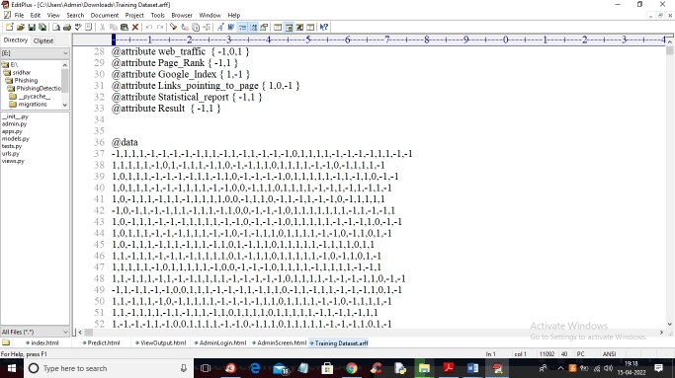
From above dataset ML algorithms can get trained but we can’t understand anything so I am using
REAL WORLD URL dataset which contains normal and phishing URLS like below screen

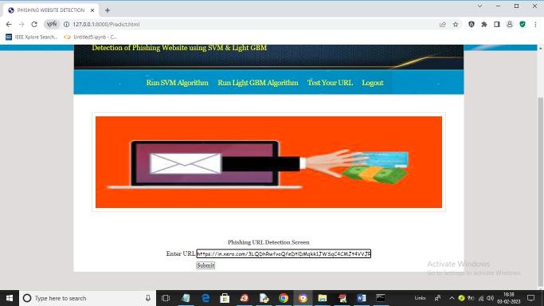

In above screen I entered same URL and press button to get below output
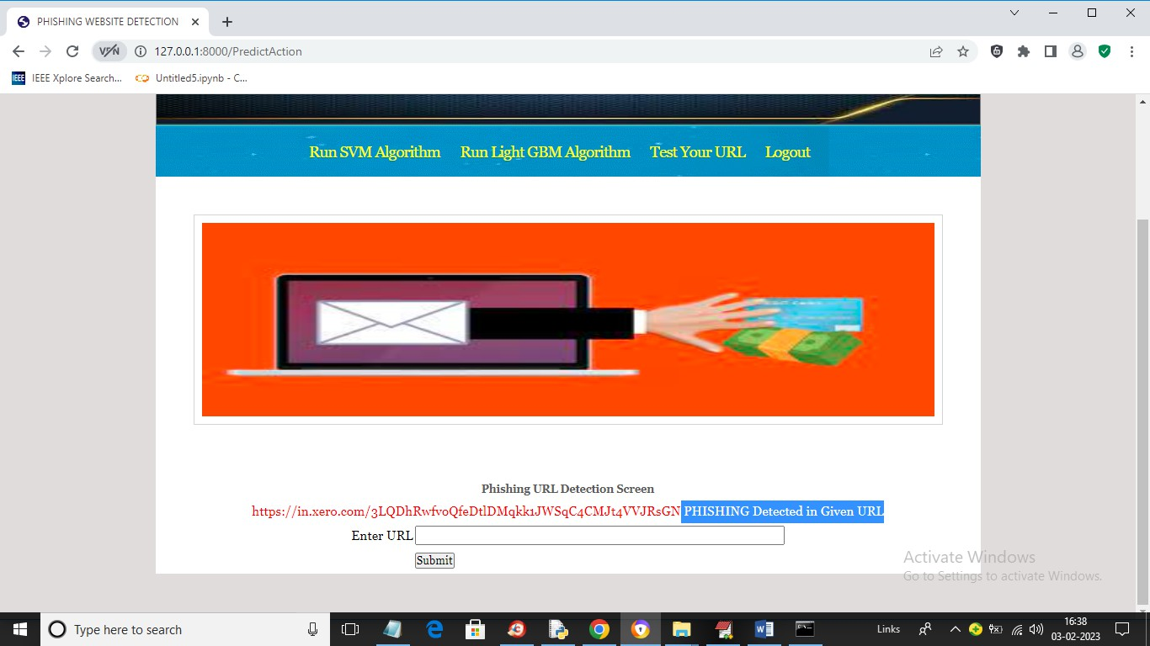

In above screen in blue colour text we can see application detected PHISHING in given URL and similarly you can enter any URL and detect it as NORMAL or phishing

CHAPTER 10 EXECUTION PROCEDURE

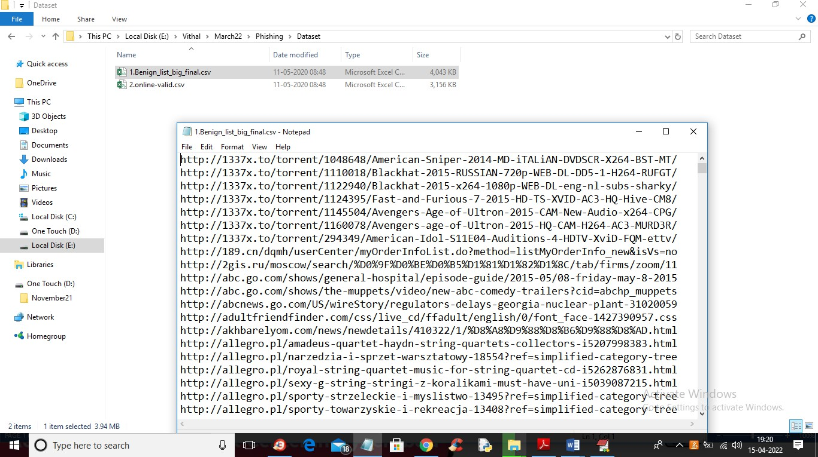
In above screen you can see our dataset contains 2 folders called benign (phishing URLS) and valid (normal URL) and this are real world URLS and we will train all algorithms with above dataset and then when we input any test URL then ML model will predict as normal or phishing
To run this project double click on ‘run.bat’ file to start python DJANO server like below
screen
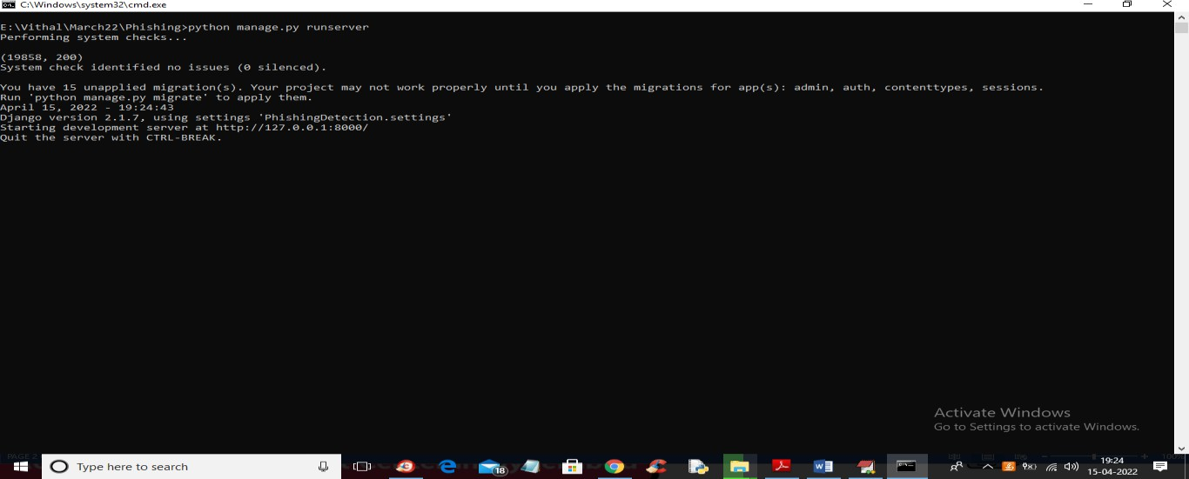
Fig 10.1 SERVER

In above screen DJANGO webserver started and now open browser and enter URL http://127.0.0.1:8000/index.html and press enter key to get below output
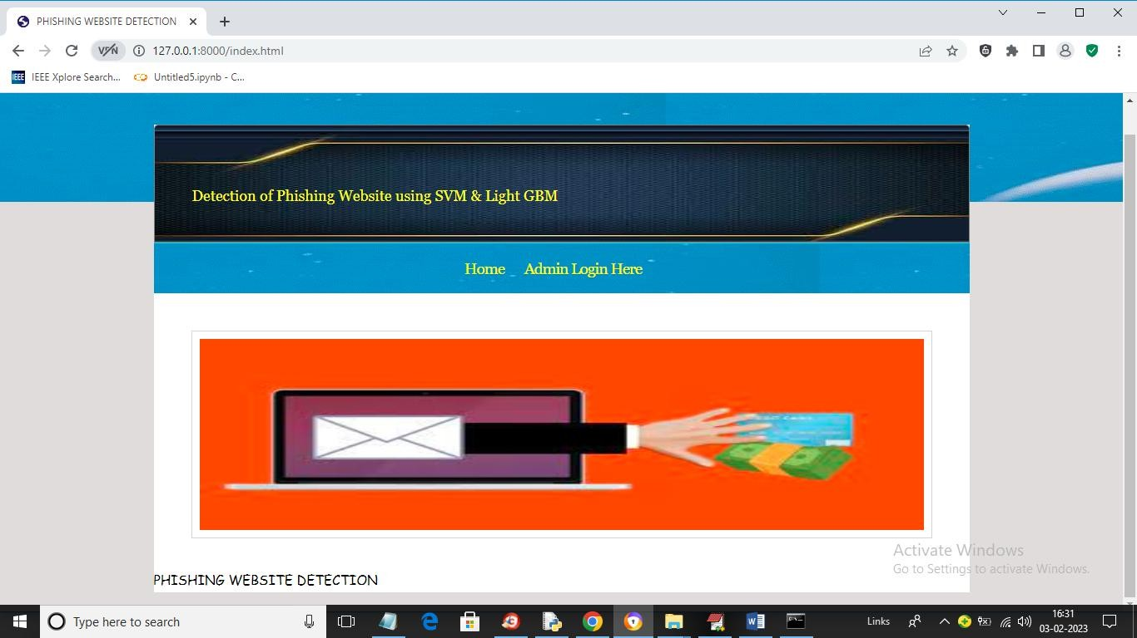
Fig 10.2 ADMIN SCREEN
In above screen click on ‘Admin Login Here’ link to get below login screen
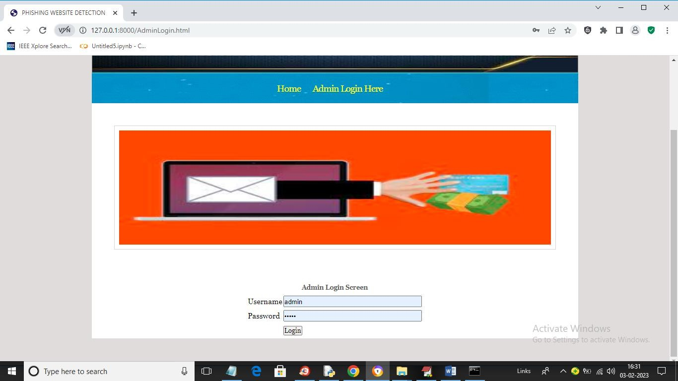
Fig 10.3 ADMIN LOGIN SCREEN
In above screen enter username and password as ‘admin’ and ‘admin’ and then press button
to get below output

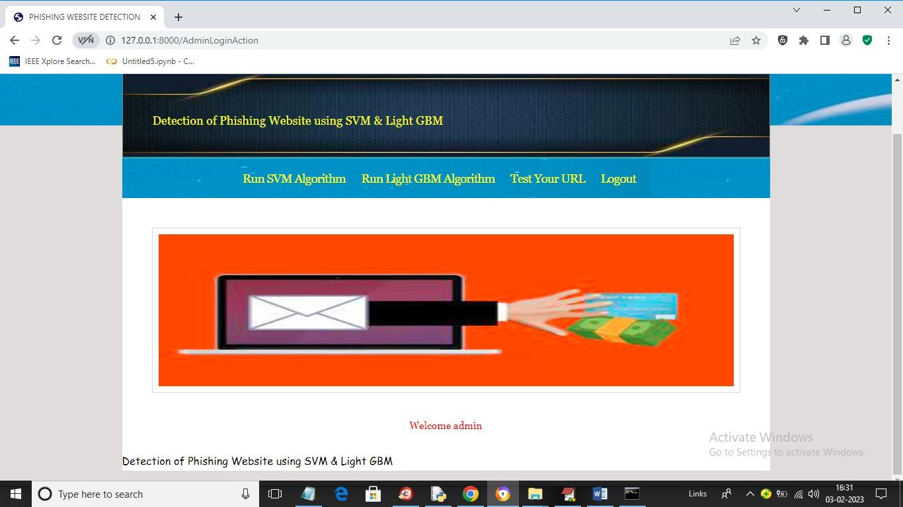
Fig 10.4 RUN TEST ALGORITHM
In above screen click on ‘Run SVM Algorithm’ link to train SVM algorithm and get below
output
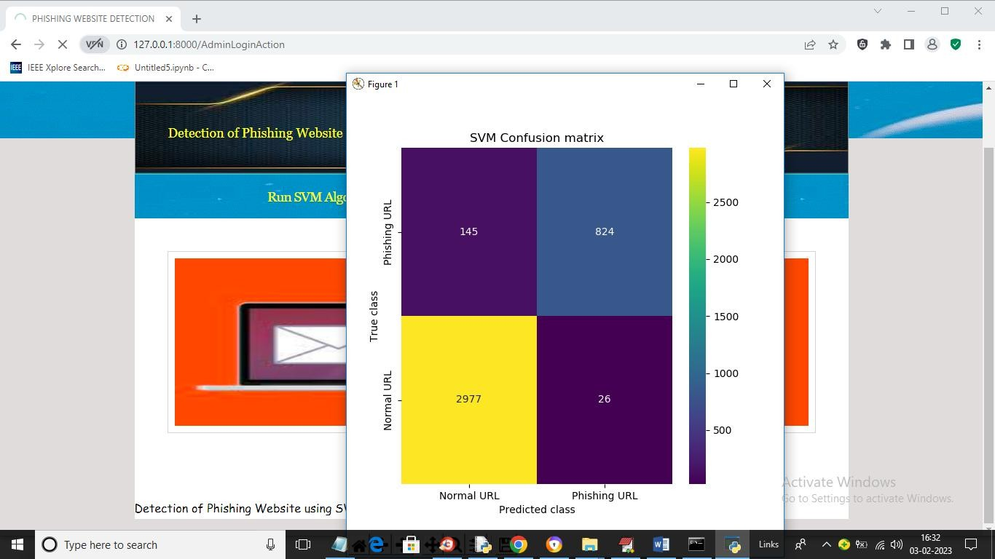
In above screen we can see SVM confusion matrix where x-axis represents predicted class and y-axis represents TRUE class and we can see SVM predict 2977 records correctly as NORMAL and only 145 are incorrect prediction and it predict 824 records as PHISHING URL and only 26 are incorrect prediction and now close above graph to get below output

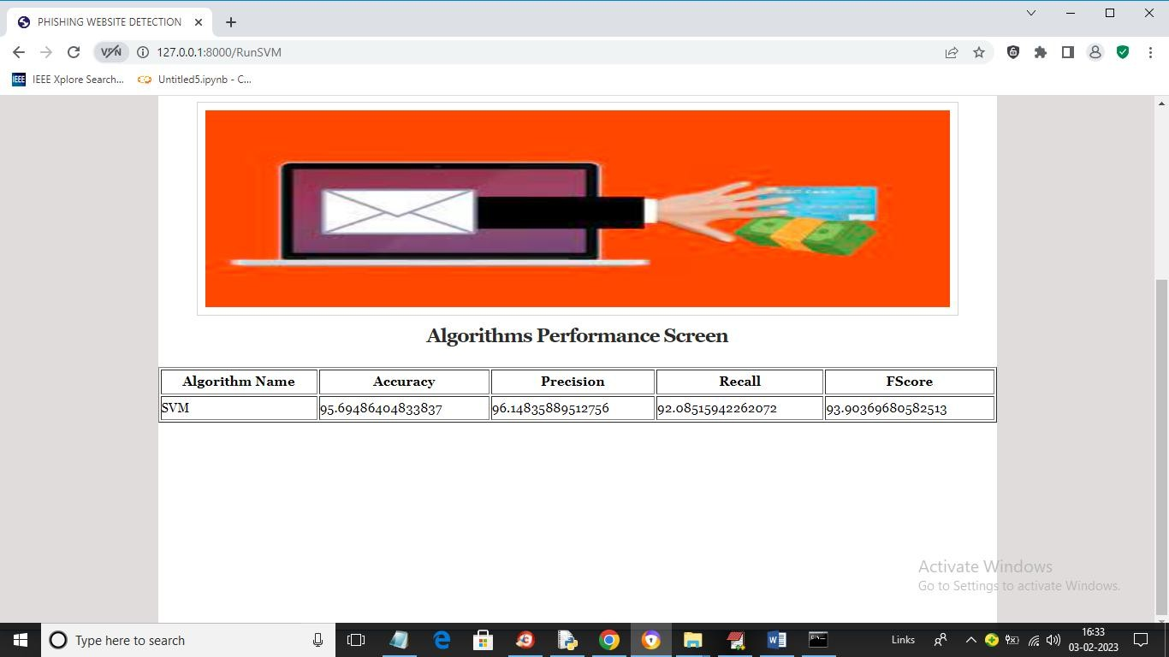
Fig 10.5 ALGORITHM PERFORMANCE SCREEN
In above screen with SVM we got 95% accuracy and now click on ‘Run Light GBM Algorithm’ link to get below output
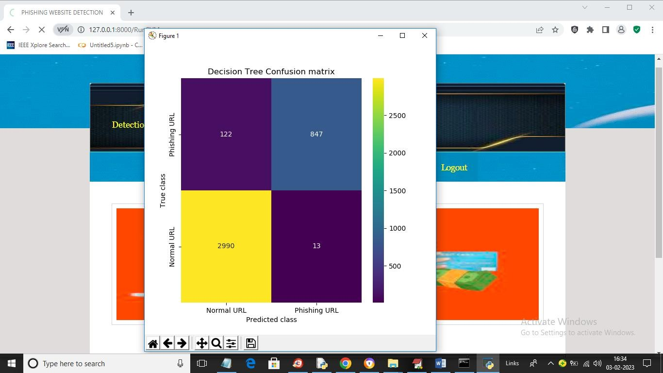
Fig 10.6 DECISION TREE CONFUSION MATRIX
In above screen we can see Decision Tree confusion matrix graph and now close above graph to get below output

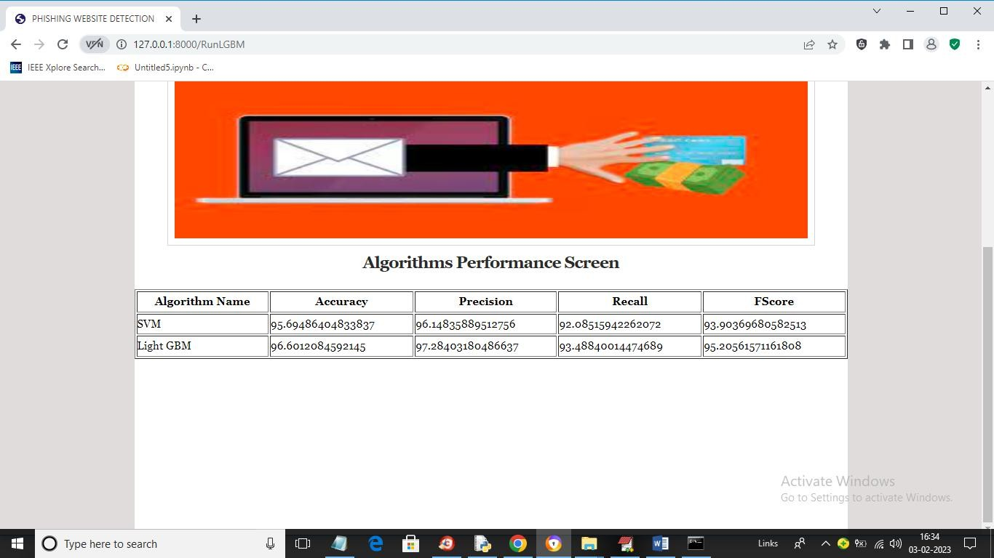
Fig 10.7 LIGHT GBM SCREEN
In above screen with Light GBM also we got 96% accuracy and now click on ‘Test Your URL’ link to get below screen
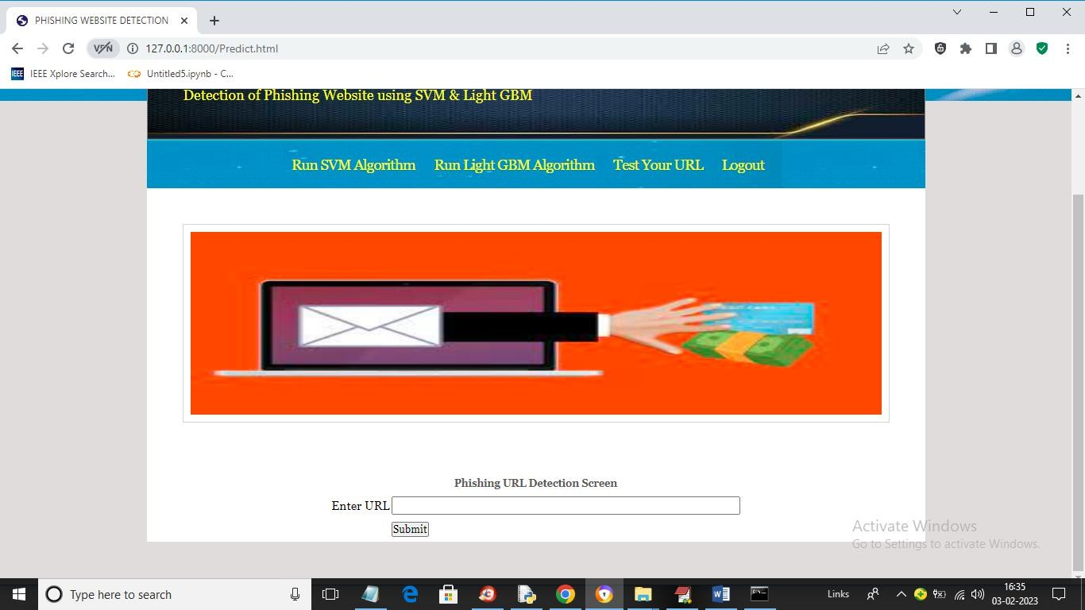
In above screen enter any URL and then press button and then Light GBM will predict whether that URL IS normal or phishing

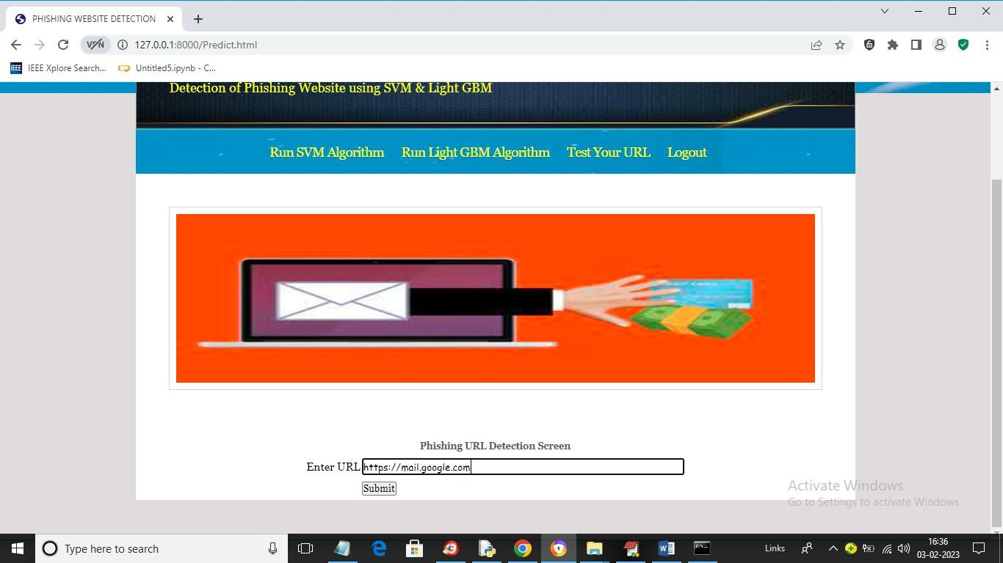

Fig 10.8 PHISHING URL DETECTION SCREEN

In above screen I entered URL as https://mail.google.com and then press button to get below output
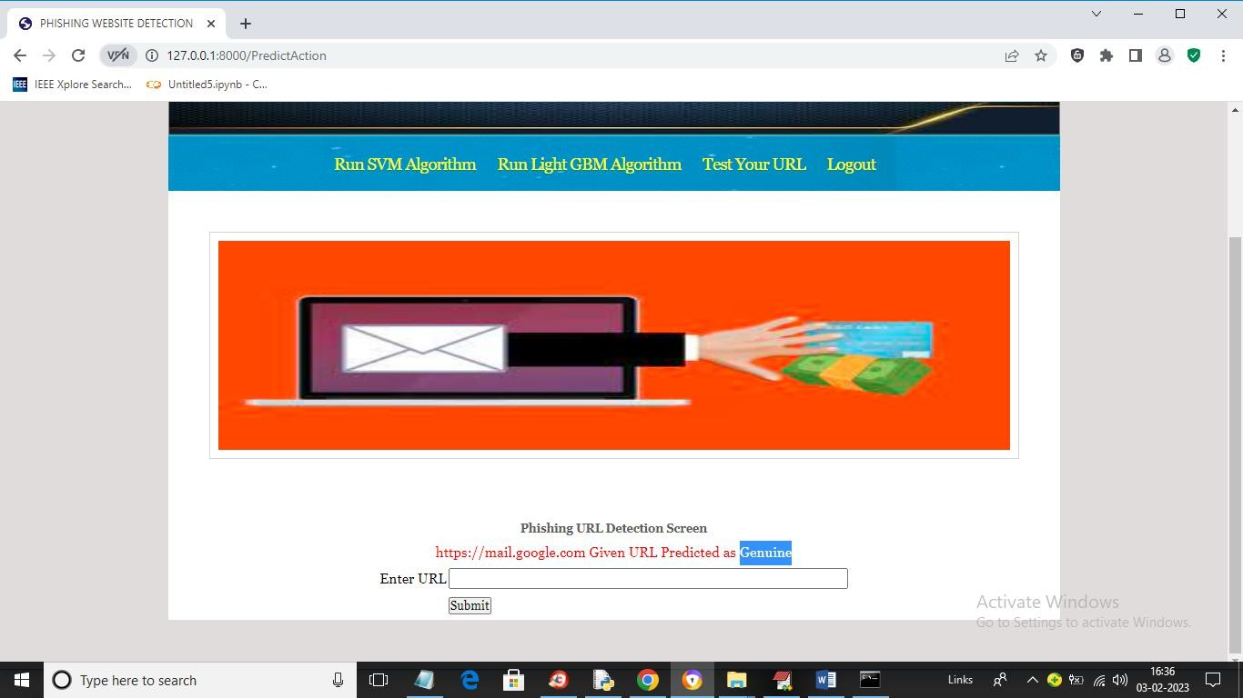

In above screen in blue colour text we can see given URL predicted as GENUINE (normal) and now test other URL. Similarly now I will enter Google.com in below screen

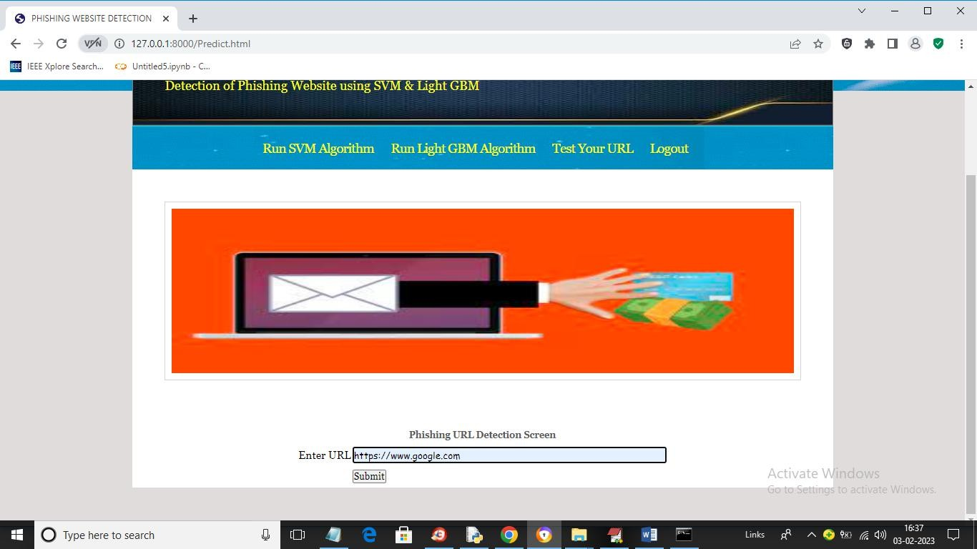

In above screen I gave URL as Google.com and below is the output
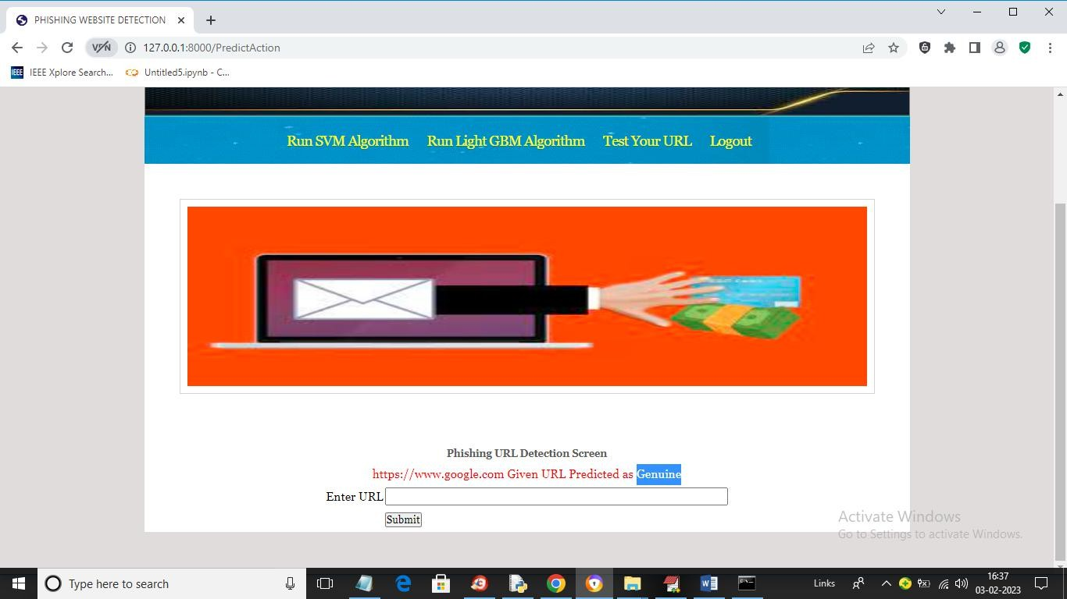

In above screen Google.com also predicted as Genuine. Now in below screen from internet I am taking one phishing URL and then input to my application to get prediction

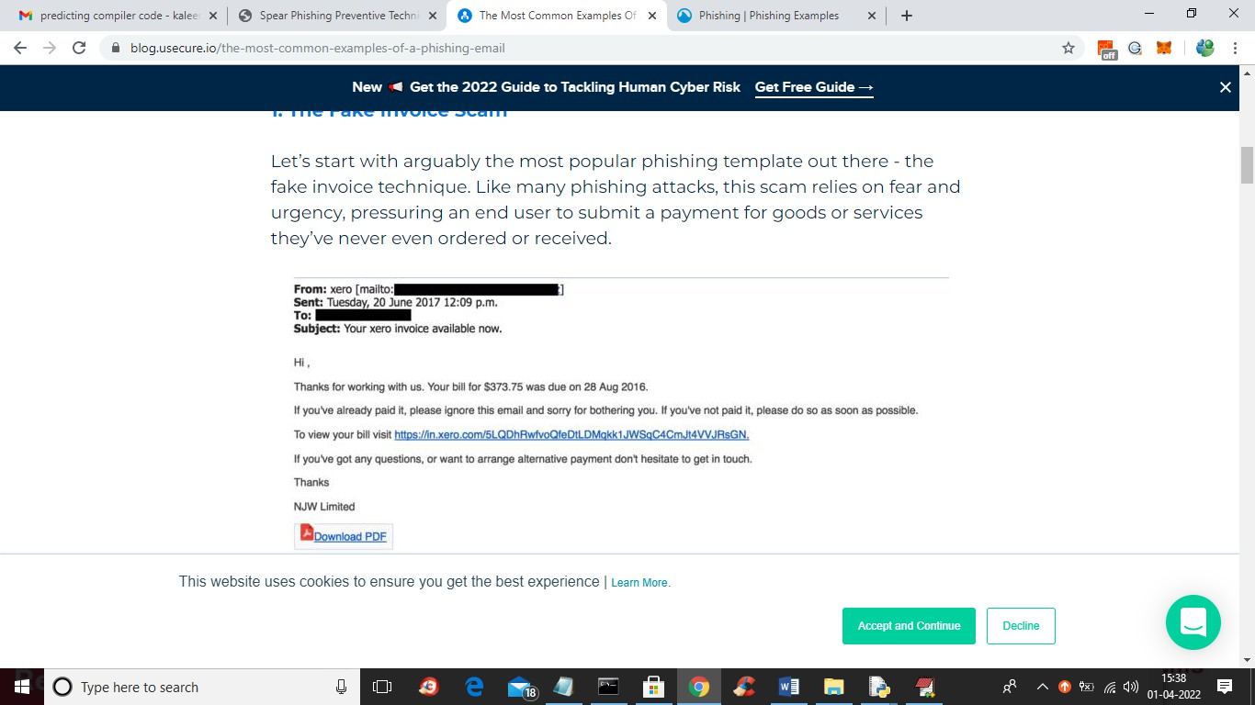

In above screen blue colour URL is the phishing URL and I will input that to my application in below screen and below is the phishing URL from internet
‘https://in.xero.com/3LQDhRwfvoQfeDtlDMqkk1JWSqC4CMJt4VVJRsGN’

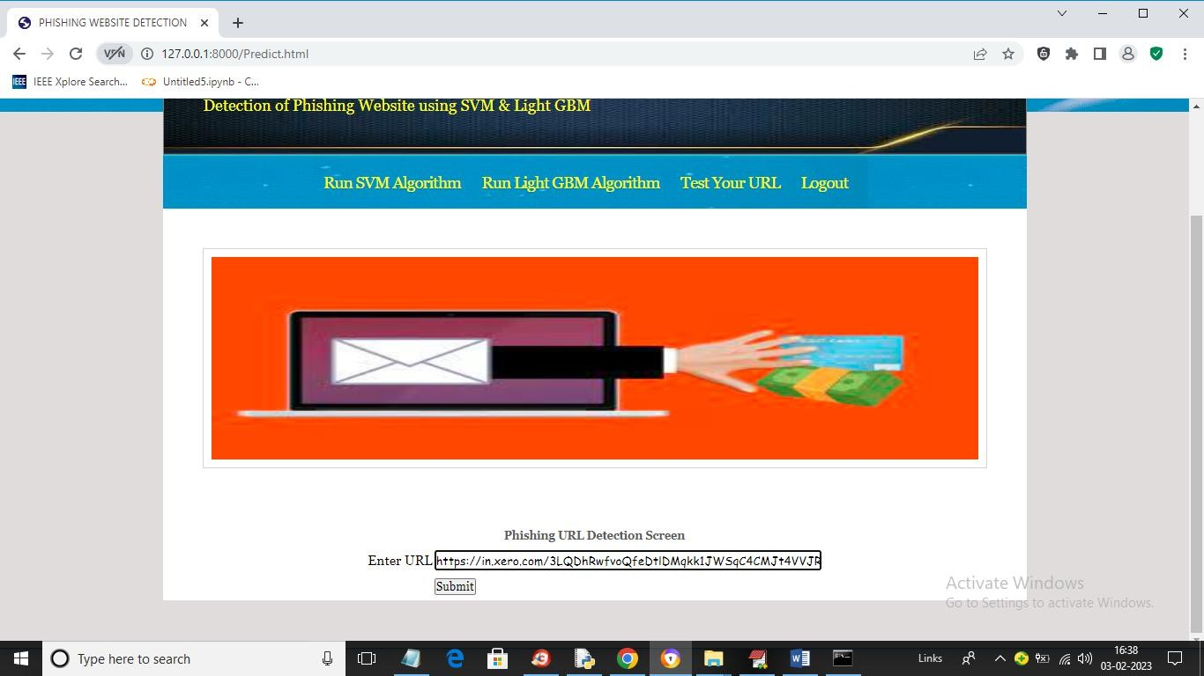

In above screen I entered same URL and press button to get below output



In above screen in blue colour text we can see application detected PHISHING in given URL and similarly you can enter any URL and detect it as NORMAL or phishing

Web Security Threat Detection
Prof.B. AMARNATHREDDY¹, KUNCHALA HEMANTH²
#1 Assistant Professor #2 M.C.A Scholar Department of Master of Computer Applications, Qis College of Engineering and Technology

ABSTRACT:
Web applications play a crucial role in modern society, offering a wide range of services from e-commerce to social networking. However, they are also a common target for cyberattacks due to their complexity and the vast amount of sensitive information they handle. Web vulnerabilities, such as SQL injection, cross-site scripting (XSS), and cross-site request forgery (CSRF), pose significant threats to the security of web applications and their users.This paper provides an overview of common web vulnerabilities, their impact, and current approaches for mitigating them. We discuss the importance of secure coding practices, regular security audits, and the use of security tools and frameworks to protect web applications from potential attacks. Additionally, we explore emerging trends and technologies, such as machine learning and artificial intelligence, that show promise in improving web application security.By understanding the nature of web vulnerabilities and implementing appropriate security measures, developers and organizations can enhance the security posture of their web applications and protect against potential threats.

INTRODUCTION:
Web applications play a crucial role in modern society, facilitating various online activities such as e-commerce, social networking, and information sharing. However, the widespread use of web applications also makes them a target for malicious actors seeking to exploit vulnerabilities for nefarious purposes. Web vulnerabilities can lead to data breaches, financial loss, and damage to an organization's reputation.Web vulnerability refers to a weakness or flaw in a web application that can be exploited by attackers to compromise the security of the application or the data it processes. These vulnerabilities can exist at various levels of the web application stack, including the web server, application server, database server, and client-side scripts.Common web vulnerabilities include SQL injection, cross-site scripting (XSS), cross-site request forgery (CSRF), and insecure direct object references. These vulnerabilities can be exploited to steal sensitive information, modify data, or execute malicious code on
the user's device.In recent years, the number and complexity of web vulnerabilities have increased, driven by the growing sophistication of attacks and the rapid evolution of web technologies. As a result, organizations must take proactive measures to identify and mitigate web vulnerabilities to protect their assets and maintain the trust of their users. The proposed system for managing web vulnerabilities aims to address the limitations of the existing system by leveraging advanced technologies and approaches. One key aspect of the proposed system is the integration of automated vulnerability scanning tools with machine learning algorithms.By using machine learning, the system can improve the accuracy of vulnerability detection and reduce false positives and false negatives. Machine learning models can be trained on large datasets of known vulnerabilities to recognize patterns and anomalies in web application code, making them more effective at identifying potential vulnerabilities.Another key component of

the proposed system is the use of continuous security testing and monitoring. Rather than relying on periodic scans or manual reviews, the system continuously monitors web applications for vulnerabilities and alerts developers in real- time. This proactive approach allows vulnerabilities to be identified and addressed promptly, reducing the risk of exploitation.Additionally, the proposed system emphasizes the importance of secure coding practices and developer training. Developers are provided with tools and resources to help them write secure code, such as secure coding guidelines and automated code analysis tools. Regular training sessions and workshops are also conducted to raise awareness about web vulnerabilities and best practices for mitigating them.
LITERATURE REVIEW:

Huang et al. (2003) – “Web Application Security Assessment by Fault Injection and Behavior Monitoring”
  - Approach: Dynamic analysis by fault injection to discover vulnerabilities.
  - Merits:
    - Can detect runtime vulnerabilities.
    - Works without needing access to source code.
  - Demerits:
    - High false positives.
    - Requires significant computational resources.

Williams and Wichers (2006) –
OWASP Top Ten Project
  - Approach: Community-driven list identifying the top 10 critical web application security risks.
  - Merits:
    - Widely accepted and updated regularly.
    - Educates developers and auditors.
  - Demerits:
    - Descriptive but not a detection method.
    - Not exhaustive; only covers the top 10.

Musch, M. et al. (2018) – “A Survey on Web Application Vulnerability Detection Tools”
  - Approach: Comparative study of static, dynamic, and hybrid tools.
  - Merits:
    - Evaluates real-world tools.
    - Identifies gaps in coverage and performance.
  - Demerits:
    - Lacks original detection techniques.
    - Results may vary based on test cases.

Fonseca et al. (2007) – “Testing and Comparing Web Vulnerability Scanning Tools for SQL Injection and XSS Attacks”
  - Approach: Empirical evaluation of scanning tools like Acunetix, Nessus, etc.
  - Merits:
    - Practical relevance for developers and testers.
    - Highlights strengths and weaknesses of each tool.
  - Demerits:
    - Limited to specific attack types (SQLi, XSS).
    - May not reflect newer vulnerabilities.

Antunes & Vieira (2015) – “Comparing the Effectiveness of Penetration Testing and Static Code Analysis”
  - Approach: Comparison of static code analysis vs. penetration testing.
  - Merits:
    - Highlights trade-offs between early detection and real-world simulation.
    - Useful for choosing the right technique.
  - Demerits:
    - Does not provide new detection algorithms.
    - Static analysis may miss logic flaws.

Doupe et al. (2010) – “Wepawet: An Automated Web Exploit Detection System for JavaScript”
  - Approach: Automated dynamic analysis of JavaScript code.
  - Merits:
    - Effective against obfuscated malware.
    - Scalable cloud-based implementation.
  - Demerits:
    - Focuses only on client-side code.
    - May not detect server-side issues.

Li et al. (2011) – “Parameterized Unit Testing for Web Security”
  - Approach: Uses unit testing with parameters to test web apps.
  - Merits:
    - Integrates with development workflows.
    - Low false positives.
  - Demerits:
    - Requires developer expertise.
    - Not effective without thorough test coverage.

SYSTEM ARCHITECTURE:

RESULTS:
In this project we are implementing SVM and Light GBM machine learning algorithms o detect phishing website URLS. We are training all this algorithms with normal and phishing URLS and build a trained model and this train model will be applied on new TEST URL to detect whether its normal or phishing URL. In this project you asked to use UCI machine learning phishing dataset but this dataset contains only 0’s and 1’s values like below screen
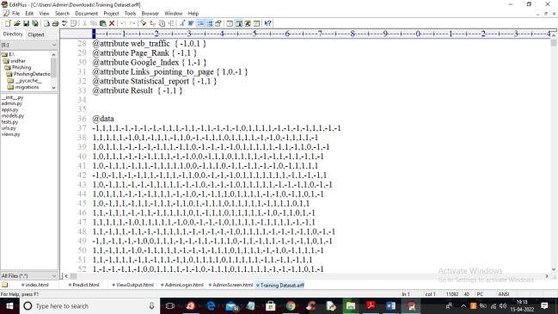
From above dataset ML algorithms can get trained but we can’t understand anything so I am using

REAL WORLD URL dataset which contains normal and phishing URLS like below screen
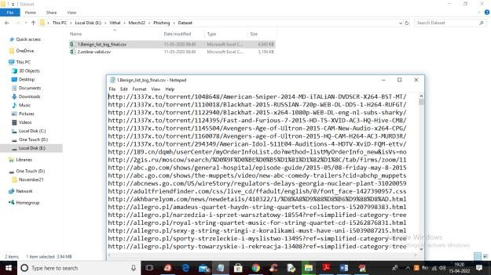
In above screen you can see our dataset contains 2 folders called benign (phishing URLS) and valid (normal URL) and this are real world URLS and we will train all algorithms with above dataset and then when we input any test URL then ML model will predict as normal or phishing
To run this project double click on ‘run.bat’ file to start python DJANO server like below screen
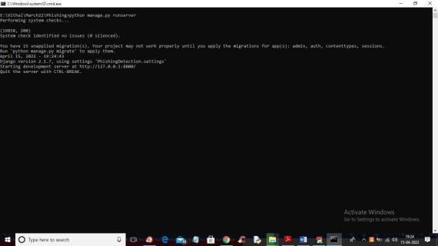
In above screen DJANGO webserver started and now open browser and enter URL
http://127.0.0.1:8000/index.html and press enter key to get below output

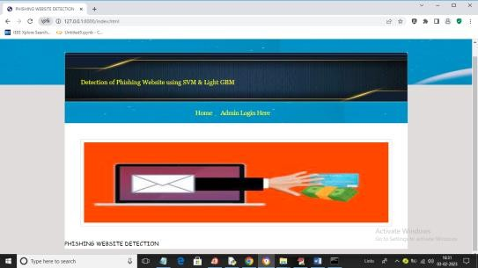
In above screen click on ‘Admin Login Here’ link to get below login screen
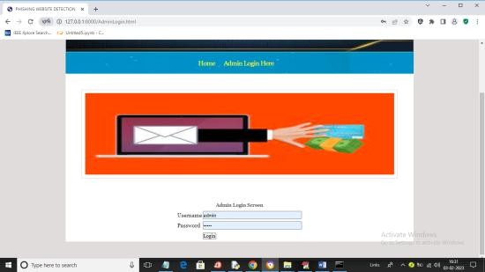
In above screen enter username and password as ‘admin’ and ‘admin’ and then press button to get below output
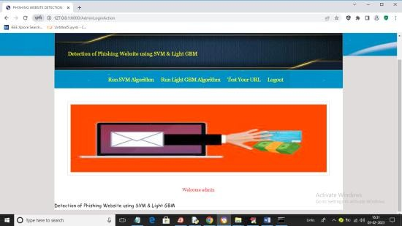
In above screen click on ‘Run SVM Algorithm’ link to train SVM algorithm and get below output
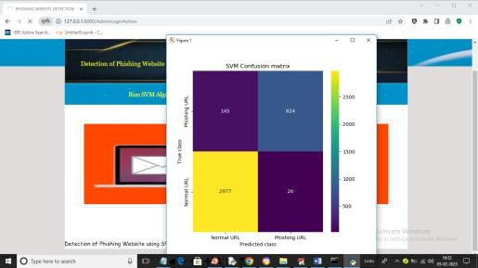
In above screen we can see SVM confusion matrix where x-axis represents predicted class and y-axis

represents TRUE class and we can see SVM predict 2977 records correctly as NORMAL and only 145 are incorrect prediction and it predict 824 records as PHISHING URL and only 26 are incorrect prediction and now close above graph to get below output
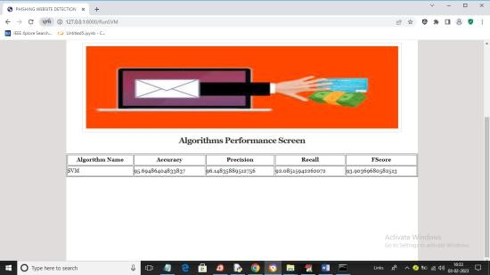
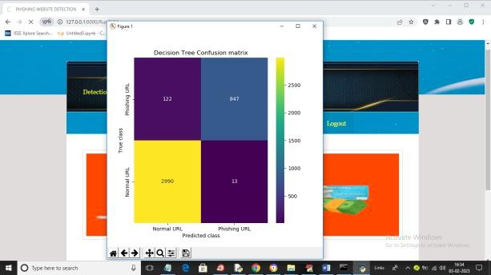
In above screen with SVM we got 95% accuracy and now click on ‘Run Light GBM Algorithm’ link to get below output

In above screen we can see Decision Tree confusion matrix graph and now close above graph to get below output
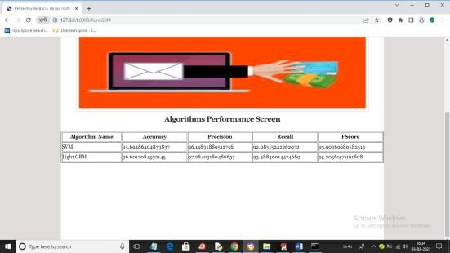
In above screen with Light GBM also we got 96% accuracy and now click
on ‘Test Your URL’ link to get below
screen
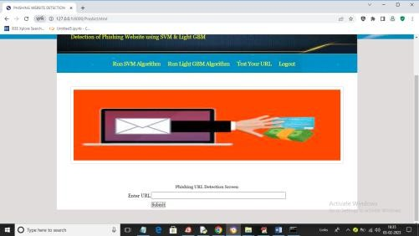
In above screen enter any URL and then press button and then Light GBM will predict whether that URL IS normal or phishing
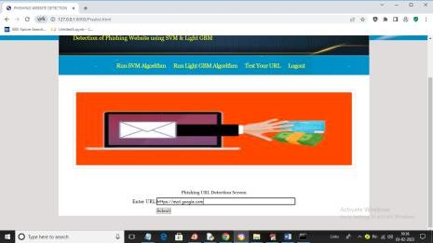
In above screen I entered URL as https://mail.google.com and then press button to get below output
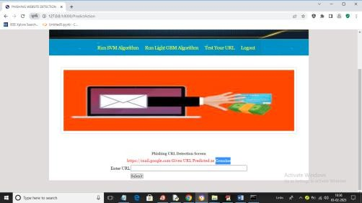
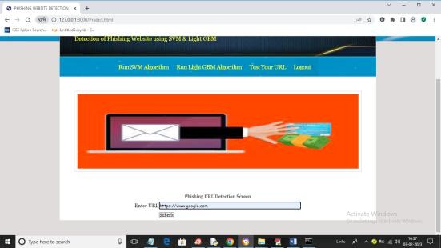
In above screen in blue colour text we can see given URL predicted as GENUINE (normal) and now test other URL. Similarly now I will enter Google.com in below screen

In above screen I gave URL as Google.com and below is the output
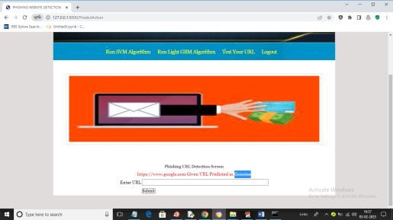
In above screen Google.com also predicted as Genuine. Now in below screen from internet I am taking one phishing URL and then input to my application to get prediction
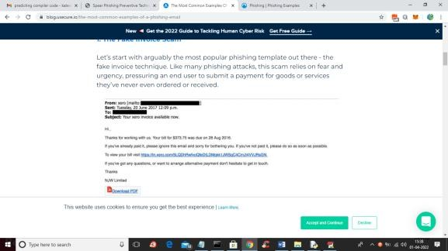
In above screen blue colour URL is the phishing URL and I will input that to my application in below screen and below is the phishing URL from internet
‘https://in.xero.com/3LQDhRwfvoQ feDtlDMqkk1JWSqC4CMJt4VVJRs GN’
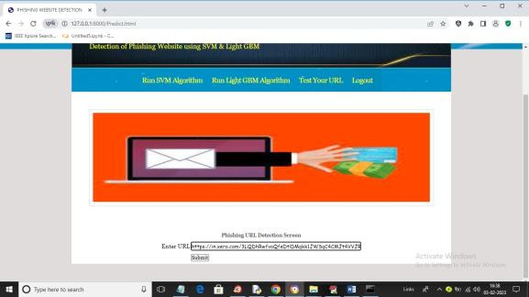
In above screen I entered same URL and press button to get below output

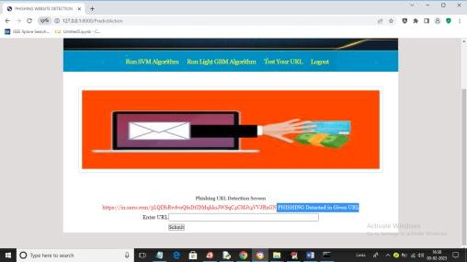
In above screen in blue colour text we can see application detected PHISHING in given URL and similarly you can enter any URL and detect it as NORMAL or phishing
CONLUSION
In conclusion, web vulnerabilities pose a significant threat to the security and integrity of web applications. Common vulnerabilities such as SQL injection, cross- site scripting (XSS), and cross-site request forgery (CSRF) can be exploited by attackers to steal sensitive information, modify data, or execute malicious code. To mitigate these vulnerabilities, organizations should implement secure coding practices, such as input validation and output encoding, to prevent vulnerabilities from being introduced into web applications. Additionally, the use of automated tools for vulnerability detection and regular security audits can help identify and address vulnerabilities in existing web applications.It is crucial for organizations to stay vigilant and proactive in addressing web vulnerabilities, as the threat landscape continues to evolve. By taking proactive measures to secure their web applications, organizations can reduce the risk of exploitation and protect their assets and reputation.

FUTURE WORK:

AI and Machine Learning-Based Detection

  - Future Direction: Develop adaptive models that can learn from web traffic patterns and detect zero- day attacks.
  - Justification: Traditional signature- based methods cannot detect novel or obfuscated vulnerabilities.
  - Challenge: Reducing false positives and maintaining model accuracy in real-time environments.

Automated Vulnerability Testing Frameworks

  - Future Direction: Create fully automated, intelligent frameworks for vulnerability discovery and remediation.
  - Justification: Manual testing is time-consuming and often incomplete.
  - Challenge: Automating logical flaw detection and contextual security analysis.

Security for Modern Web Technologies

  - Future Direction: Explore vulnerabilities in Single Page Applications (SPAs), Progressive Web Apps (PWAs), and WebAssembly.
  - Justification: These technologies are increasingly used but less understood in terms of their security implications.
  - Challenge: Tooling support and lack of mature security best practices.

Vulnerability Detection in APIs and Microservices

  - Future Direction: Design security testing tools specifically tailored for REST, GraphQL, and microservice communication.
  - Justification: Web apps are increasingly backend-driven with APIs as primary attack vectors.
  - Challenge: Dynamic environments and complex access control policies.

Human-Centric Security Models

  - Future Direction: Incorporate user behavior and human error modeling into web security tools.
  - Justification: Many security breaches stem from social engineering or misconfiguration.
  - Challenge: Balancing usability and security in real-world applications.

Secure Development Lifecycle Integration

  - Future Direction: Embed security testing and vulnerability scanning into CI/CD pipelines.
  - Justification: Early detection reduces remediation costs and improves quality.
  - Challenge: Avoiding performance bottlenecks and ensuring developer adoption.

Better Defense Mechanisms Against Client-Side Attacks

  - Future Direction: Strengthen defenses against client-side attacks like DOM-based XSS and clickjacking.
  - Justification: Client-side logic is expanding and becoming a primary target.

  - Challenge: Browsers vary in support for policies like CSP, and developers often misconfigure them.

Privacy and Compliance-Oriented Security

  - Future Direction: Align vulnerability assessment with GDPR, CCPA, and other compliance standards.
  - Justification: Web vulnerabilities increasingly intersect with data privacy laws.
  - Challenge: Legal and technical integration of privacy and security testing.

Real-Time Monitoring and Response Systems

  - Future Direction: Implement systems for real-time detection and automated mitigation of attacks.
  - Justification: Rapid response minimizes impact from exploits.
  - Challenge: Ensuring accuracy and low-latency without affecting performance.

Security Awareness and Developer Education

  - Future Direction: Enhance developer tools and training focused on secure coding practices.
  - Justification: Most vulnerabilities are introduced during development.
  - Challenge: Keeping training relevant as threats evolve.

REFERENCES:
- Halfond, W. G., Orso, A., & Manolios, P. (2006). AMNESIA: Analysis and Monitoring for NEutralizing SQL-Injection Attacks. In Proceedings of the 20th
IEEE/ACM International Conference on Automated Software Engineering (ASE'06).

- Huang, Y., Huang, C., Su, S., & Lee, J. (2014). A Survey on Web Application Security. Journal of Software, 9(1), 218-
228.

- Barth, A., Jackson, C., & Mitchell, J. C. (2008). Robust Defenses for Cross-Site Request Forgery. In Proceedings of the 15th ACM Conference on Computer and Communications Security (CCS '08). Authors:
Mr. B. Amarnath Reddy is an Assistant Professor in the Department of Master of Computer Applications at QIS College of Engineering and Technology, Ongole, Andhra Pradesh. He earned his M.Tech from Vellore Institute of Technology(VIT), Vellore. His research interests include Machine Learning, Programming Languages. He is committed to advancing research and fostering innovation while mentoring students to excel in both academic and professional pursuits.

